

**Introduction to Data science**

**Lab Manual**

**IYear (I/II semester)**

Batch: 2020-21

**School of Computer Science and Engineering**

**And**

**School of Computer Science and Information Technology**

**(Common for all programmes)**

|  |  |
| --- | --- |
| **Name** |  |
| **SRN** |  |
| **Branch** |  |
| **Semester** |  |
| **Section** |  |
| **Academic Year** |  |

**Index**

|  |  |  |
| --- | --- | --- |
| **Sl.No.** | **Particulars** | **Page no.** |
| **1** | **Continuous Assessment Form** | **3** |
| **2** | **Semester End Examination Practical evaluation procedure 2020-21** | **5** |
| **3** | **Course Description** | **6** |
| **4** | **Course Objectives** | **6** |
| **5** | **Course Outcomes** | **6** |
| **6** | **List of experiments** |  |
| **7** | **Part-A- Experiments** |  |
| **8** | **Part B – Mini Project** |  |
| **9** | **Additional Data Science Projects** |  |
| **10** | **Appendix-Installation Guide** |  |

**CONTINUOUS ASSESMENT**

**PART-A**

|  |  |  |  |  |
| --- | --- | --- | --- | --- |
| **Slno.** | **Experiment Name** | **Max. Marks** | **Obtained Marks** | **Sign** |
| 1 |  |  |  |  |
| 2 |  |  |  |  |
| 3 |  |  |  |  |
| 4 |  |  |  |  |
| 5. |  |  |  |  |
| 6 |  |  |  |  |
| 7 |  |  |  |  |
| 8 |  |  |  |  |
| 9 |  |  |  |  |
| 10 |  |  |  |  |
| 11 |  |  |  |  |
| 12 |  |  |  |  |
|  | **Total Marks** | **10** |  |  |

**PART-B**

|  |  |  |  |  |
| --- | --- | --- | --- | --- |
| **Slno.** | **Experiment Name** | **Max. Marks** | **Obtained Marks** | **Sign** |
| 1 |  |  |  |  |
| 2 |  |  |  |  |
|  | **Total Marks** | **10** |  |  |

|  |  |  |  |
| --- | --- | --- | --- |
| **Internal Assesment / Additional Assignments** | **Max. Marks** | **Obtained Marks** | **Sign** |
|  | 05 |  |  |

**Total Marks Obtained : /25**



**Semester End Examination Practical Evaluation Procedure 2020-2021 (ODD / EVEN)**

|  |  |  |  |  |
| --- | --- | --- | --- | --- |
| **Python Lab (Part A and Part B):** | | | | |
| Q. | **Parameters to be Considered** | | **Marks Distribution** | **Total** |
| A. | Write UP | Manual Calculation- Steps | 5 | 20 |
| Result obtained from manual calculation |
| Conduction & Results | Results obtained using Excel tool | 5 |
|  | Write UP | Manual Calculation- Steps | 5 |  |
| Result obtained from manual calculation |
| Conduction & Results | Results obtained using Excel tool | 5 |
|  | Viva | | 05 | 05 |
|  | TOTAL | |  | 25 |

**Note: Lab course is conducted for a total of 50 Marks:**

1. 25 Marks Continuous Evaluation
2. 25 Marks Semester End Examination

**COURSE Description**

Data Science is an interdisciplinary, problem-solving oriented subject that is used to apply scientific techniques to practical problems. The course orients on preparation of datasets and programming of data analysis tasks. This course covers the topics: ML algorithms, SQL and demonstration of experiments by using MS-Excel and MySQL

**COURSE OBJECTIVE (S):**

The objectives of this course are to:

1. Explain the fundamental concepts of Excel.

2. Explain the algorithms of Machine learning.

3. Demonstrate the use of SQL commands in real world applications.

4. Discuss the functional components of Data Science for real world applications

**COURSEOUTCOMES(COs)**

After the completion of the course, the student will be able to:

|  |  |  |  |
| --- | --- | --- | --- |
| CO# | Course Outcomes | POs | PSOs |
| CO1 | Make use of the concepts of Data Science in developing the real world applications. | 1, 2, 4,10 | 1,2,3 |
| CO2 | Apply the SQL commands in developing the real-world applications. | 1,2, 3,9,10 | 2, 3 |
| CO3 | Build the solutions for real world problems, perform analysis, interpretation and reporting of data using regression alogorithms. | 2,3, 4, 8,9, 10 | 1, 2, 3 |
| C04 | Design ER diagrams for database. | 2,3, 4,8, 9, 10 | 1, 2, 3 |

**BLOOM’S LEVEL OF THE COURSE OUTCOMES**

|  |  |  |  |  |  |  |
| --- | --- | --- | --- | --- | --- | --- |
| CO# | Bloom’s Level | | | | | |
| Remember(L1) | Understand(L2) | Apply(L3) | Analyze(L4) | Evaluate(L5) | Create(L6) |
| CO1 |  |  | ✓ |  |  |  |
| CO2 |  |  | ✓ |  |  |  |
| CO3 |  |  | ✓ | ✓ |  |  |
| C04 |  |  | ✓ | ✓ | ✓ | ✓ |

**TABLE OF CONTENTS**

|  |  |  |  |  |
| --- | --- | --- | --- | --- |
| **No** | **Title of the Experiment** | **Tools andTechniques** | **Expected Skill/Ability** | **Page No.** |
| 1 | The height(in cm) of a group of fathers and sons are given below, Find the line of regression and estimate the height of son when the height of father is 164 cm. Plot the graph   |  |  |  |  |  |  |  |  |  |  |  | | --- | --- | --- | --- | --- | --- | --- | --- | --- | --- | --- | | Hgt of Fathers | 158 | 166 | 163 | 165 | 167 | 170 | 167 | 172 | 177 | 181 | | Hgt of Sons | 163 | 158 | 167 | 170 | 160 | 180 | 170 | 175 | 172 | 175 | | MS Excel | Create and perform operations on Excel data set by applying Linear regression | 18 |
| 2 | Using the data file [DISPOSABLE INCOME AND VEHICLE SALES](https://wps.prenhall.com/wps/media/objects/973/997180/dataset_questions/disposable_income.xls), perform the following:   1. Plot a scatter diagram. 2. Determine the regression equation. 3. Plot the regression line (hint: use MS Excel's Add Trendline feature). 4. Compute the predicted vehicle sales for disposable income of $16,500 and of $17,900. 5. Compute the coefficient of determination and the coefficient of correlation | MS Excel | Perform prediction and visualization of data | 24 |
| 3 | Managers model costs in order to make predictions. The cost data in the data file [INDIRECT COSTS AND MACHINE HOURS](https://wps.prenhall.com/wps/media/objects/973/997180/dataset_questions/indirect_costs_machine_hours.xls) show the indirect manufacturing costs of an ice-skate manufacturer. Indirect manufacturing costs include maintenance costs and setup costs. Indirect manufacturing costs depend on the number of hours the machines are used, called machine hours. Based on the data for January to December, perform the following operations.   1. Plot a scatter diagram. 2. Determine the regression equation. 3. Plot the regression line (hint: use MS Excel's Add Trendline feature). 4. Compute the predicted indirect manufacturing costs for 300 machine hours and for 430 machine hours. 5. Compute the coefficient of determination and the coefficient of correlation 6. Compute the coefficient of determination and the coefficient of correlation. | MS Excel | Perform prediction and visualization of data | 32 |
| 4 | Apply multiple linear regression to predict the stock index price which is a dependent variable of a fictitious economy based on two independent / input variablesinterest rateand unemployment rate.   |  |  |  |  |  | | --- | --- | --- | --- | --- | | year | month | interest rate | unemployment rate | stock index price | | 2020 | 10 | 2.75 | 5.3 | 1464 | | MS Excel | Perform prediction and visualization of data | 40 |
| 5. | Calculate the total interest paid on a car loan which has been availed from HDFC bank. For example, Rs.10,00,000 has been borrowed from a bank with annual interest rate of 5.2% and the customer needs to pay every month as shown in table below. Calculate the total interest rate paid for a loan availed of Rs.10,00,000during 3 years.   |  |  |  | | --- | --- | --- | | Sl No. | A | B | | 1 | Principal | Rs.10,00,000 | | 2 | Annual interest rate | 5.20% | | 3 | Year of the loan | 3 | | 4 | Starting payment number | 1 | | 5 | Ending payment number | 36 | | 6 | total interest paid during period | ? | | MS Excel | Create Excel data and perform EMI estimator | 45 |
| 6 | Create a supplier database of 10 records with SUPPLIER_ID as primary key, SUPPLIER_NAME, PRODUCTS, QUANTITY, ADDRESS, CITY,PHONE_NO and PINCODE, Where SUPPLIER_NAME, PRODUCTS, QUANTITY and PHONE_NO, should not be NULL. | SQL | Creating Tables | 47 |
| 7 | Create the customer database of a big Market withCUSTOMER_IDas primary key,CUSTOMER_NAME, PHONE_NO, EMAIL_ID, ADDRESS, CITY and PIN_CODE.Store at least twenty customers details where CUSTOMER_NAME and PHONE_NO are mandatory and display the customer data in alphabetical order. | SQL | Creating and retrieving Tables | 49 |
| 8 | Apply linear regression to find the weather (temperature) of a city with the amount of rain in centimeters. Create your own database with following details.   |  |  |  | | --- | --- | --- | | CITY | Temperature in Centigrade | Rain in Centimeters | |  |  |  | | MS Excel | Apply Linear regression | 55 |
| 9 | Use the linear regression technique to compare the age of humans with the amount of sleep in hours.   |  |  |  | | --- | --- | --- | | Name | Age in Years | Sleep in hours |   Create your own database with above details. | MS Excel | Apply Linear regression | 59 |
| 10 | Apply the linear regression, compare the average salaries of batsman depending on the run rate scored/ recorded in the matches.Assume your own database. | MS Excel | Apply Linear regression | 63 |
| 11 | Design the ER diagram and create schema of the REVA library management system. | Entity Relationship | Entity Relationship diagrams | 67 |
| 12 | Design the ER diagram and create schema for Hospital Management system. | Entity Relationship | Schema design | 69 |

**PART_B:Projects**

|  |  |  |  |  |
| --- | --- | --- | --- | --- |
| **No** | **Titleof the Experiment** | **Tools andTechniques** | **Expected Skill/Ability** | **Page No.** |
| 1 | Big Mart sales forecasting | MS Excel | Apply Linear regression | 71 |
| 2 | Bangalore crime analysis | MS Excel | Apply Linear regression | 74 |

**PART-A**

**Experiments**

1. **The height(in cm) of a group of fathers and sons are given below,Find the lines of regression and estimate the height of son when the height of father is 164 cm.**

|  |  |  |  |  |  |  |  |  |  |  |
| --- | --- | --- | --- | --- | --- | --- | --- | --- | --- | --- |
| **Hgt of Fathers** | **158** | **166** | **163** | **165** | **167** | **170** | **167** | **172** | **177** | **181** |
| **Hgt of Sons** | **163** | **158** | **167** | **170** | **160** | **180** | **170** | **175** | **172** | **175** |

**Solution:**

Step 1: Height data have been taken from dataset.

|  |  |
| --- | --- |
| Hgt of Fathers | Hgt of Sons |
| 158 | 163 |
| 166 | 158 |
| 163 | 167 |
| 165 | 170 |
| 167 | 160 |
| 170 | 180 |
| 167 | 170 |
| 172 | 175 |
| 177 | 172 |
| 181 | 175 |

|  |  |  |  |  |  |  |  |  |  |  |
| --- | --- | --- | --- | --- | --- | --- | --- | --- | --- | --- |
| Ht. of fathers | 158 | 166 | 163 | 165 | 167 | 170 | 167 | 172 | 177 | 181 |
| Ht. of sons | 163 | 158 | 167 | 170 | 160 | 180 | 170 | 175 | 172 | 175 |

Step 2: Enter the data for Independent Variable x and dependent variable y as shown above 11 values

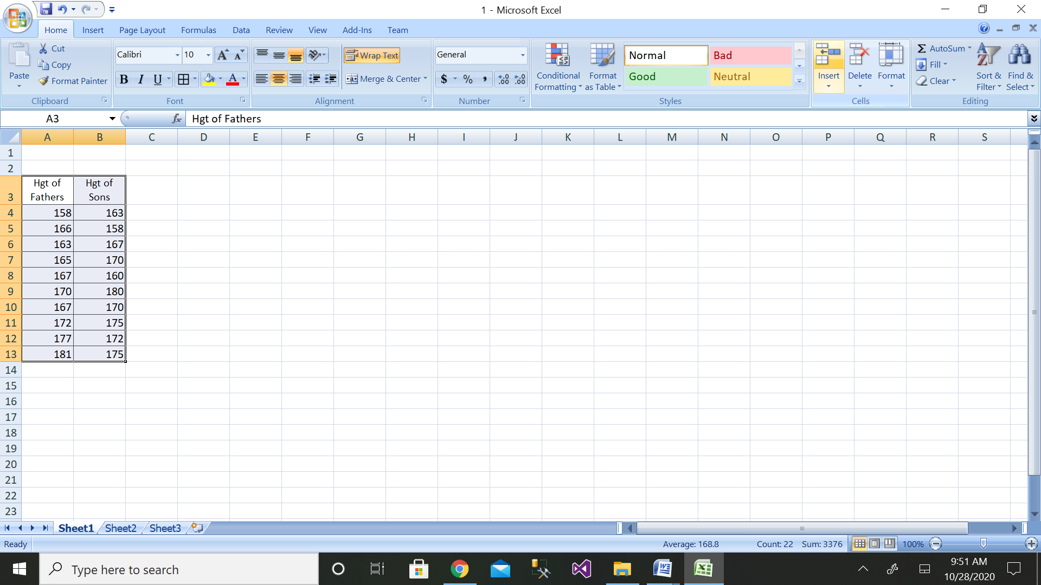

Step 3: Then click on the Data Analysis button

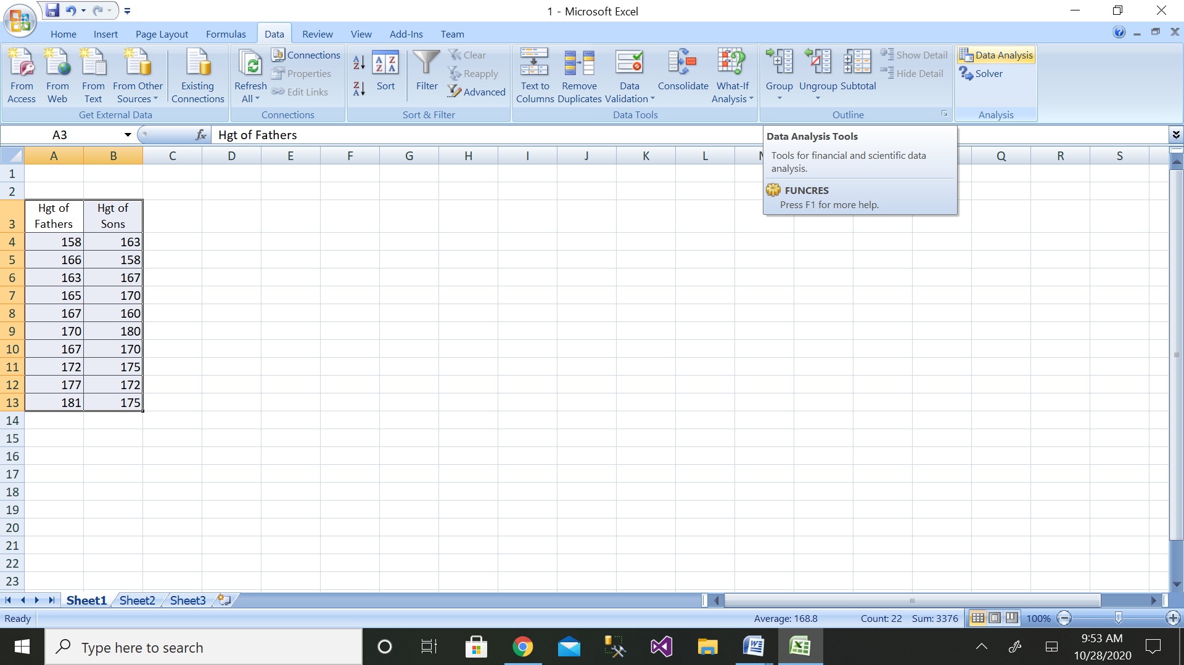

Step 4: Then click on the Regression button

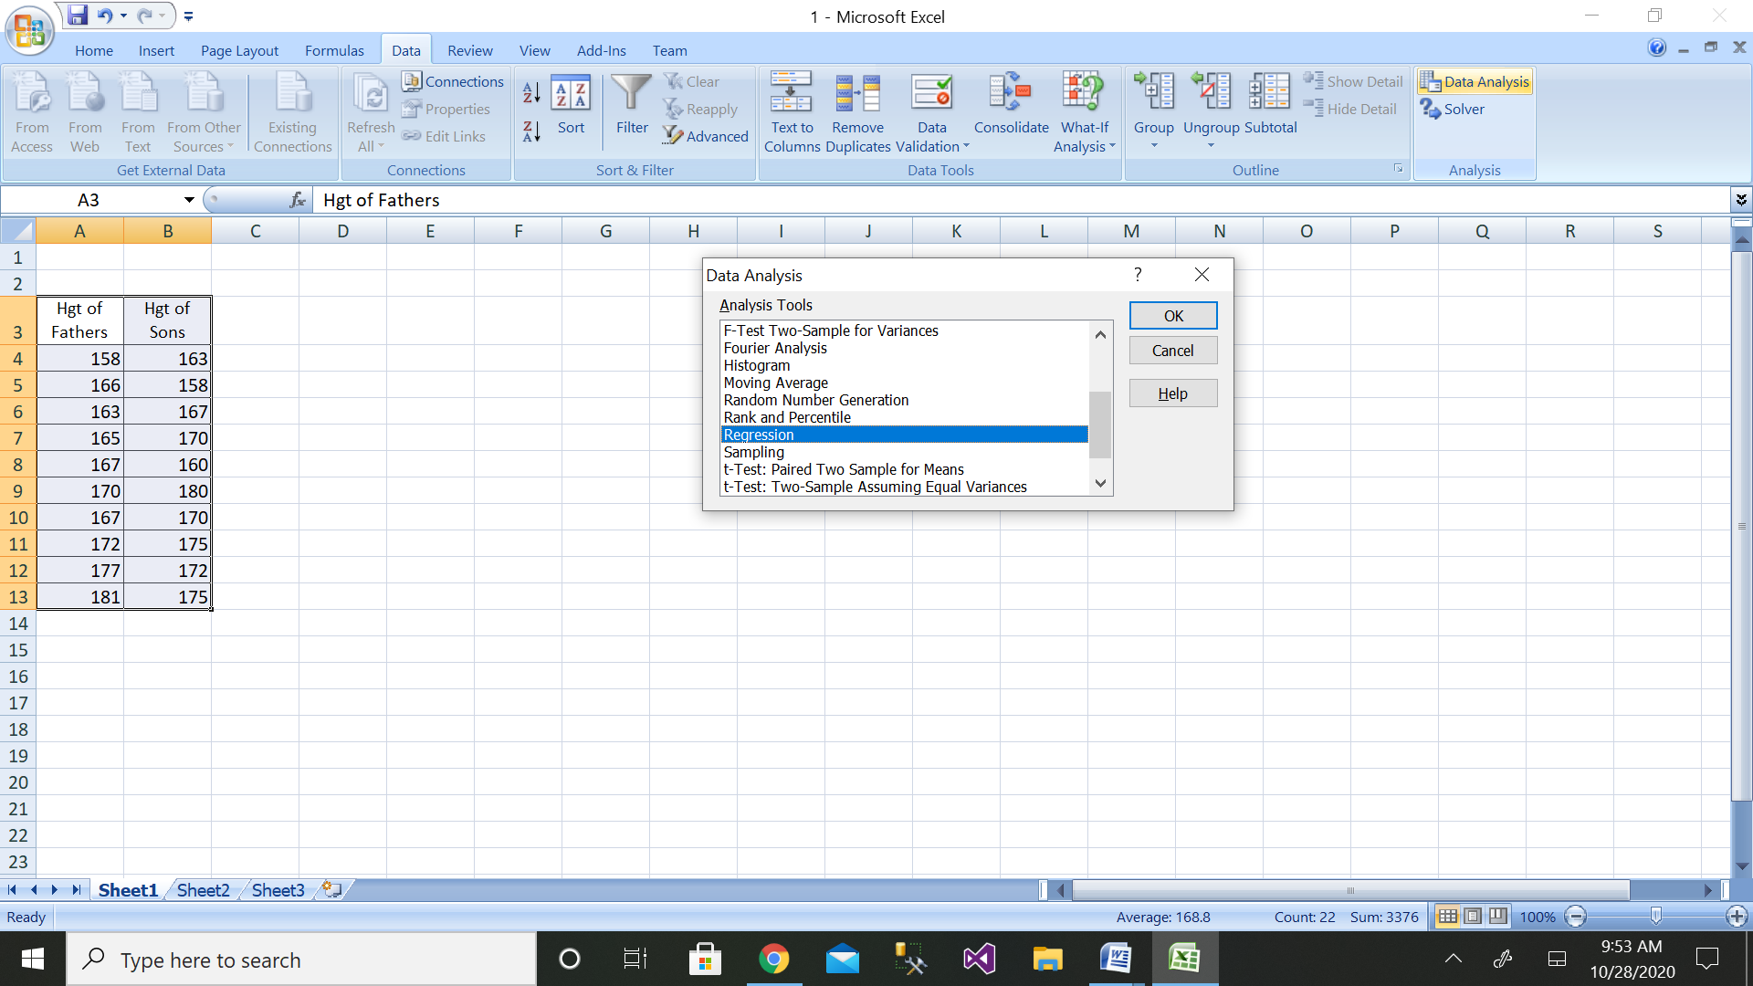

Step 5: Then select the range of dependent variable as shown above

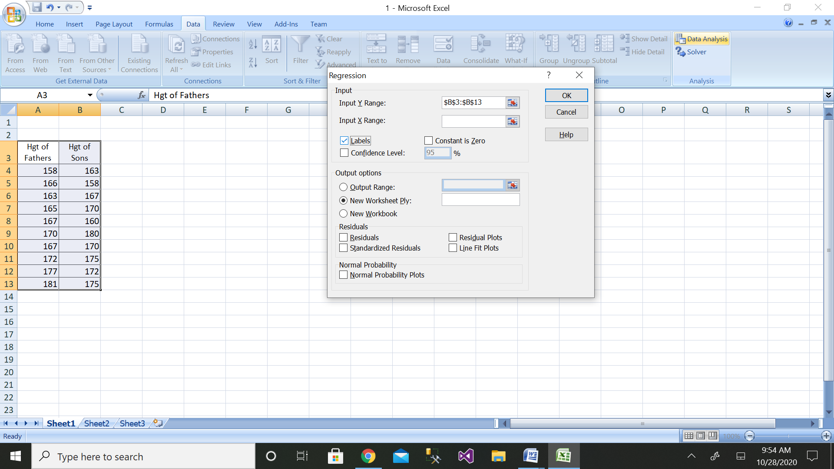

Step 6: After selecting both ranges click on ok button

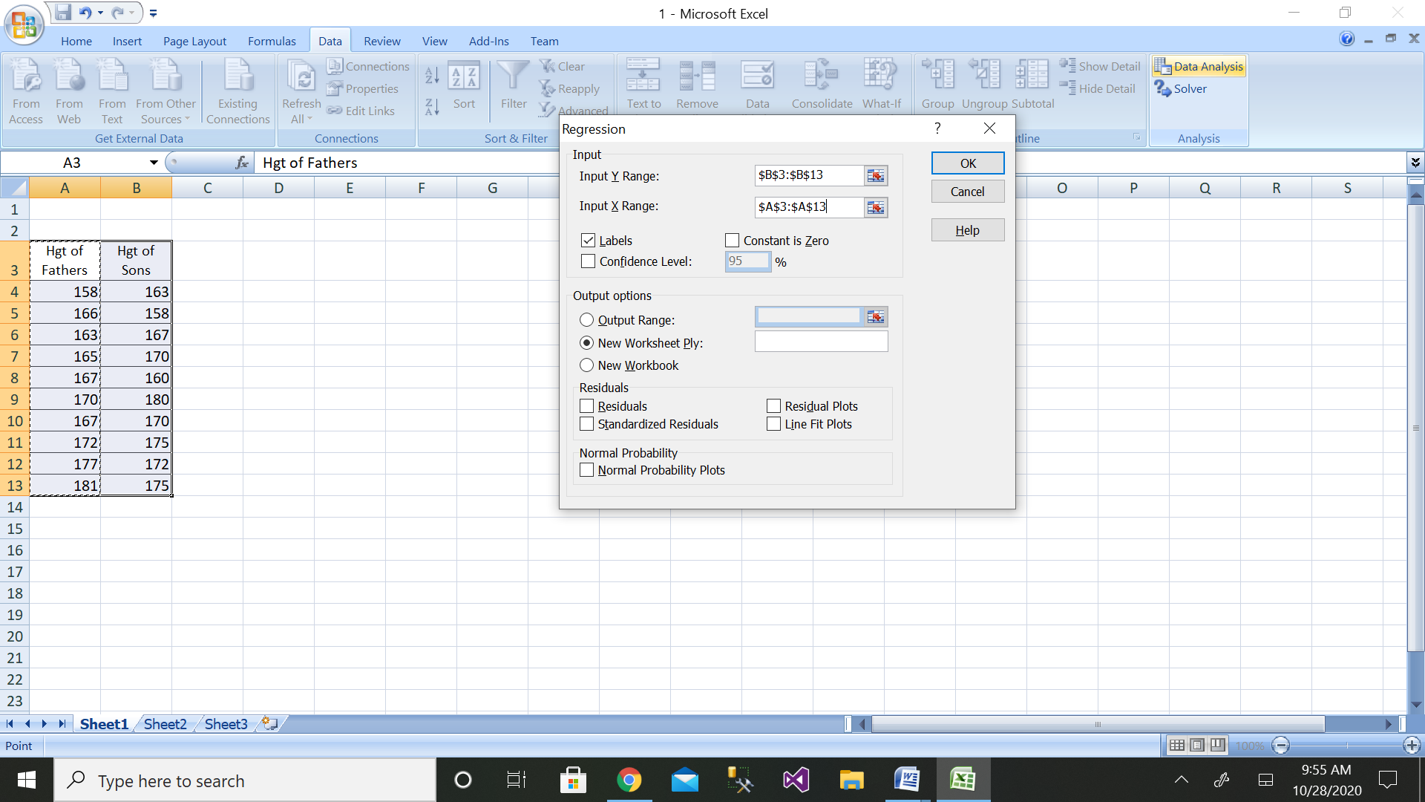

Step 7: We will get the output as shown with residual plot graph

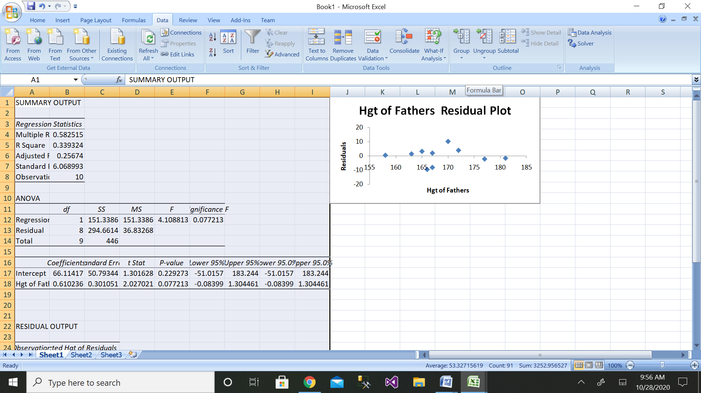

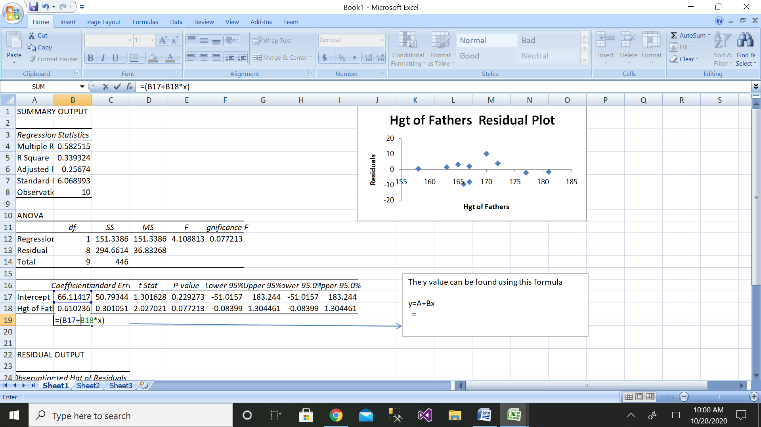

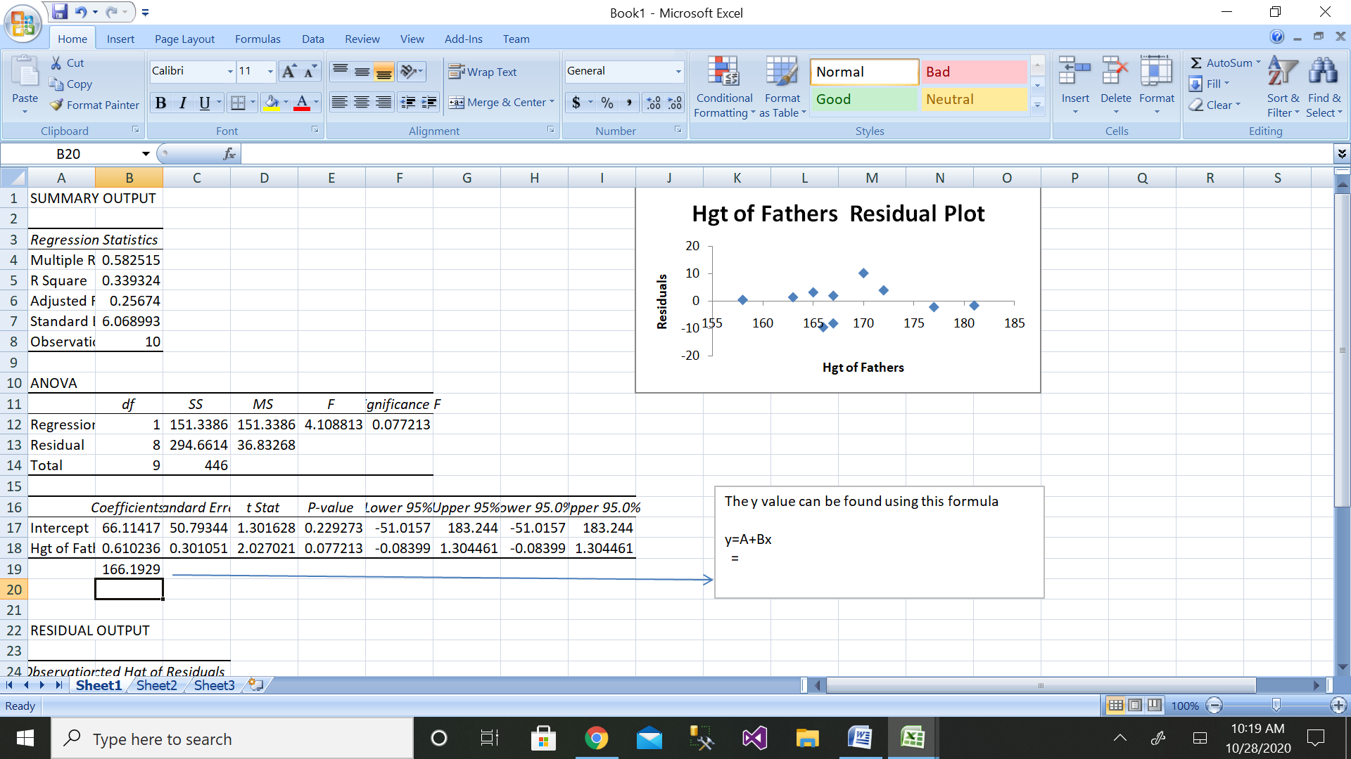

The height of son when son of father is 164cm is as follows:

Y=A+Bx

=66.11417+164*0.610236

=166.1929

Manual calculation

|  |  |  |  |  |  |  |  |
| --- | --- | --- | --- | --- | --- | --- | --- |
| Sl. No. | height of father (x) | | height of son(y) | x-mean(x) | y-mean(y) | x-mean(x) * y-mean(y) | x-mean(x)^2 |
| 1 | 158 | 163 | | -10.6 | -6 | 63.6 | 112.36 |
| 2 | 166 | 158 | | -2.6 | -11 | 28.6 | 6.76 |
| 3 | 163 | 167 | | -5.6 | -2 | 11.2 | 31.36 |
| 4 | 165 | 170 | | -3.6 | 1 | -3.6 | 12.96 |
| 5 | 167 | 160 | | -1.6 | -9 | 14.4 | 2.56 |
| 6 | 170 | 180 | | 1.4 | 11 | 15.4 | 1.96 |
| 7 | 167 | 170 | | -1.6 | 1 | -1.6 | 2.56 |
| 8 | 172 | 175 | | 3.4 | 6 | 20.4 | 11.56 |
| 9 | 177 | 172 | | 8.4 | 3 | 25.2 | 70.56 |
| 10 | 181 | 175 | | 12.4 | 6 | 74.4 | 153.76 |
|  |  |  | |  |  |  |  |
|  | sum(x) | sum(y) | | 0.00 | 0 | 248 | 406.40 |
|  | 1686 | 1690 | |  |  |  |  |
|  | mean(x) | mean(y) | |  |  |  |  |
|  | 168.6 | 169 | |  |  |  |  |
|  |  |  | |  |  |  |  |
|  | coefficient of regression=byx | **byx= ∑ (x- x¯ )(y−y¯)/ (x−x¯)2**  ((sum(x-mean(x) *y-mean(y)) ) / (x-mean(x)^2) | | 0.61023622 | 0.61023622 |  |  |
|  |  |  | |  |  |  |  |
|  | calculate y intercept | C=mean(y)-byx*mean(x) | |  | 66.11417323 |  |  |
|  |  |  | |  |  |  |  |
|  | dependent variable=y=C+byx*x |  | | 166.192913 |  |  |  |

**2. Using the data file** [**DISPOSABLE INCOME AND VEHICLE SALES**](https://wps.prenhall.com/wps/media/objects/973/997180/dataset_questions/disposable_income.xls)**, perform the following:**

1. **Plot a scatter diagram.**
2. **Determine the regression equation.**
3. **Plot the regression line (hint: use MS Excel's Add Trendline feature).**
4. **Compute the predicted vehicle sales for disposable income of $16,500 and of $17,900.**

**Compute the coefficient of determination and the coefficient of correlation**

**Solution:** Sales data have been taken from dataset.

|  |  |
| --- | --- |
| disposable income | vehicle sales |
| 15000 | 200 |
| 28000 | 300 |
| 18000 | 180 |
| 19000 | 190 |
| 22000 | 220 |
| 25000 | 250 |
| 10000 | 100 |
| 29000 | 285 |

a)

Scatter diagram is as follows:

b) Regression equation is as follows:

y=A+Bx

c)Regression line:

d)

Step 1: Enter the data for Independent Variable x and dependent variable y as shown above 8 values

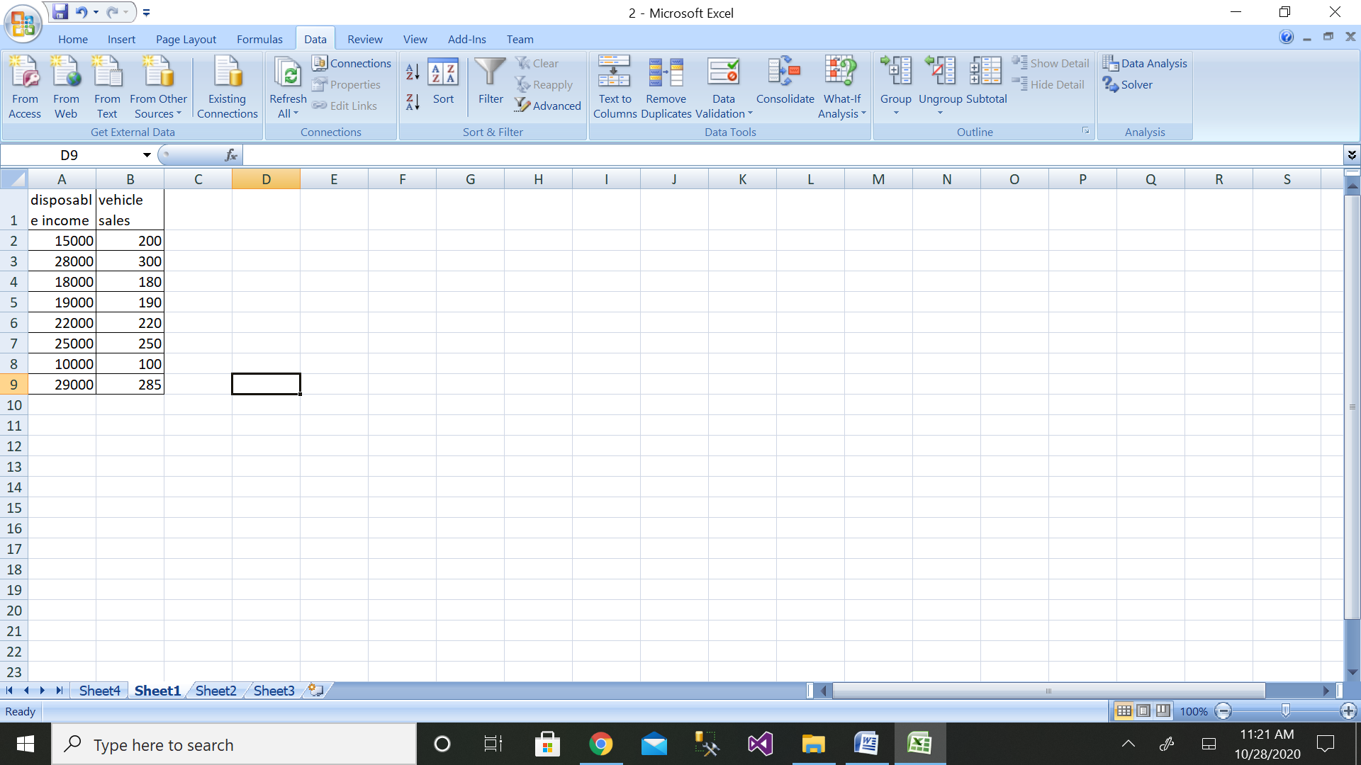

Step 2: Then click on the Data Analysis button

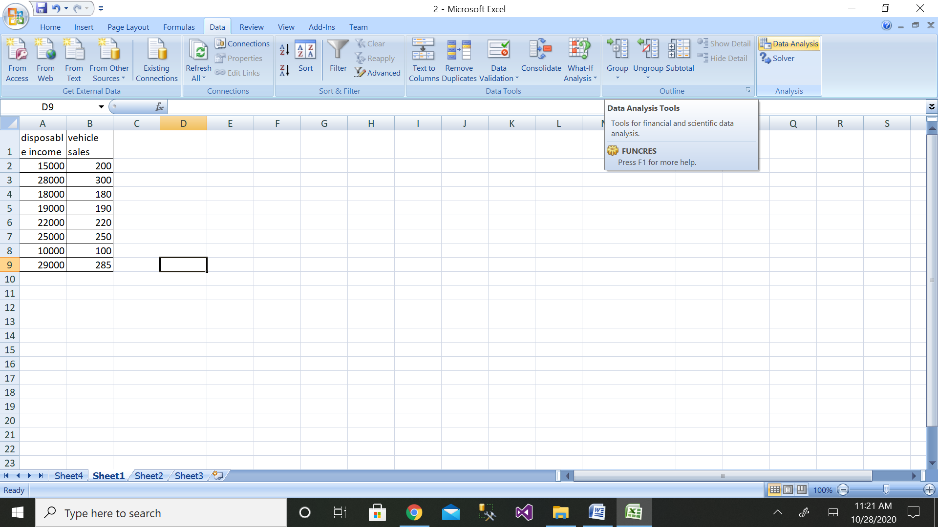

Step 4: Then click on the Regression button

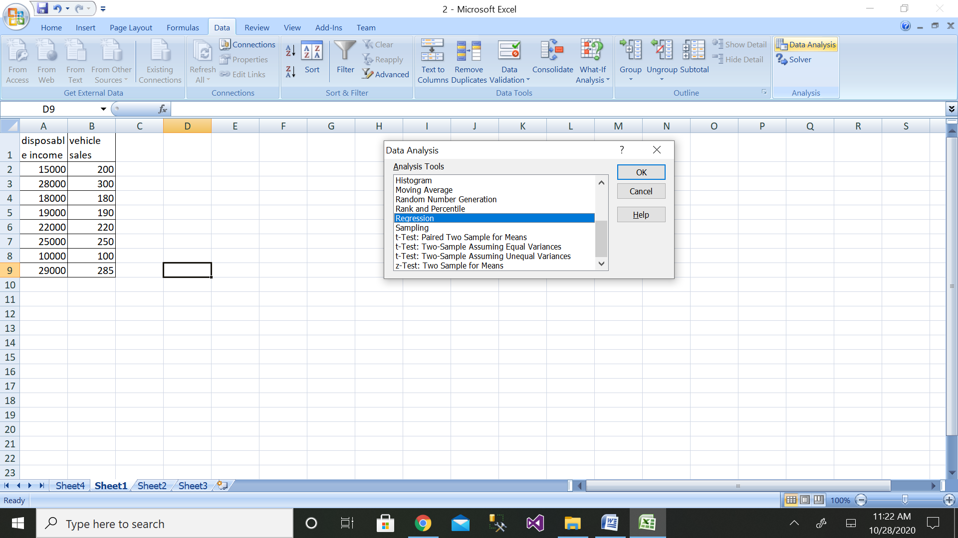

Step 4: Then select the range of dependent variable as shown above

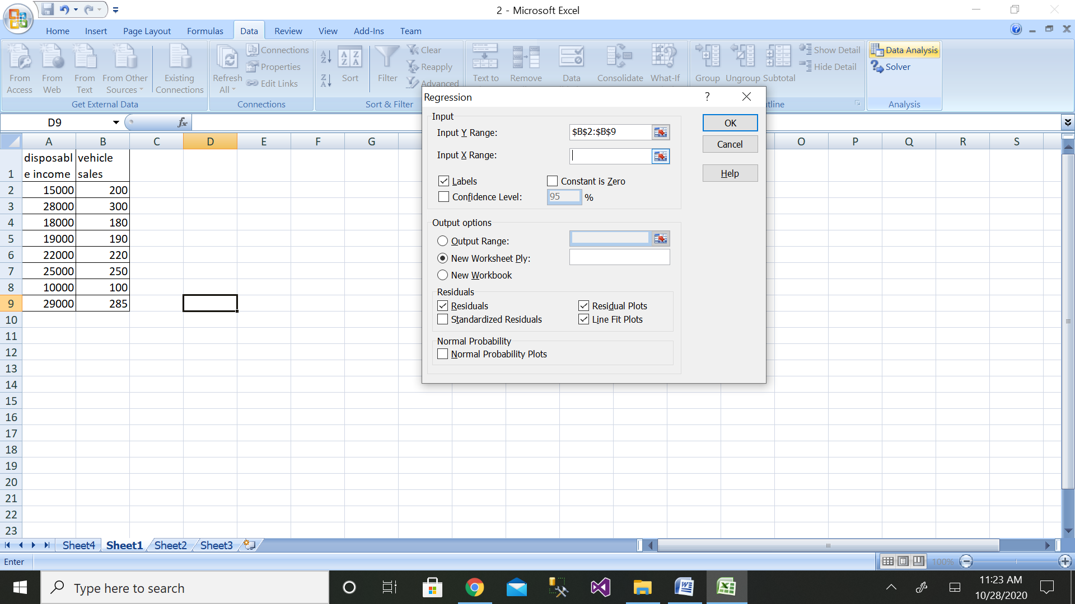

Step 6: After selecting both ranges click on ok button

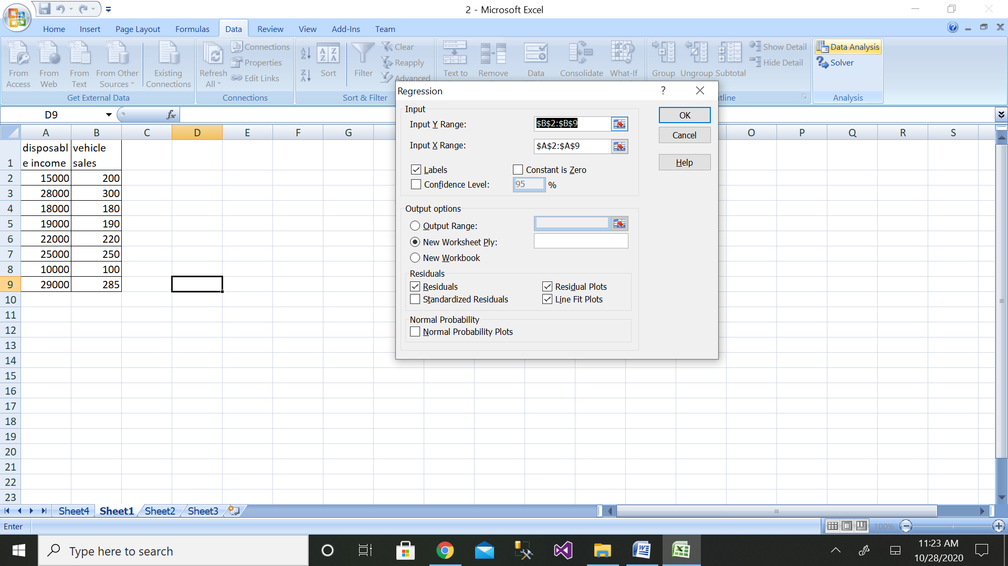

Step 7: We will get the output as shown with residual plot graph

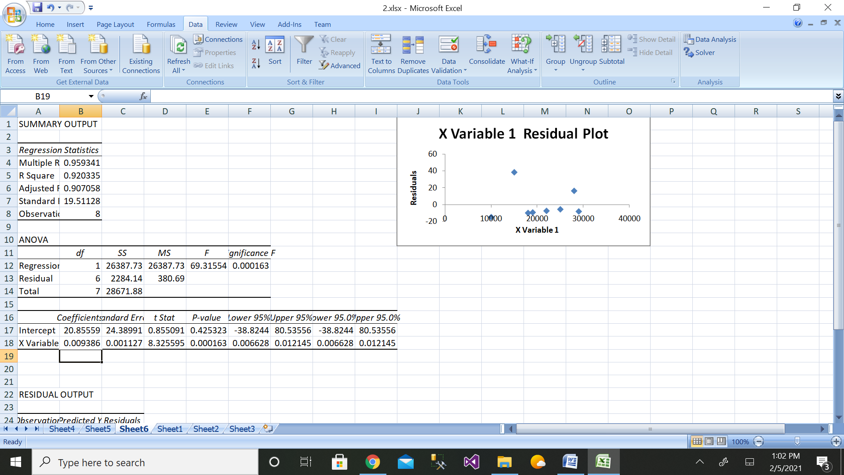

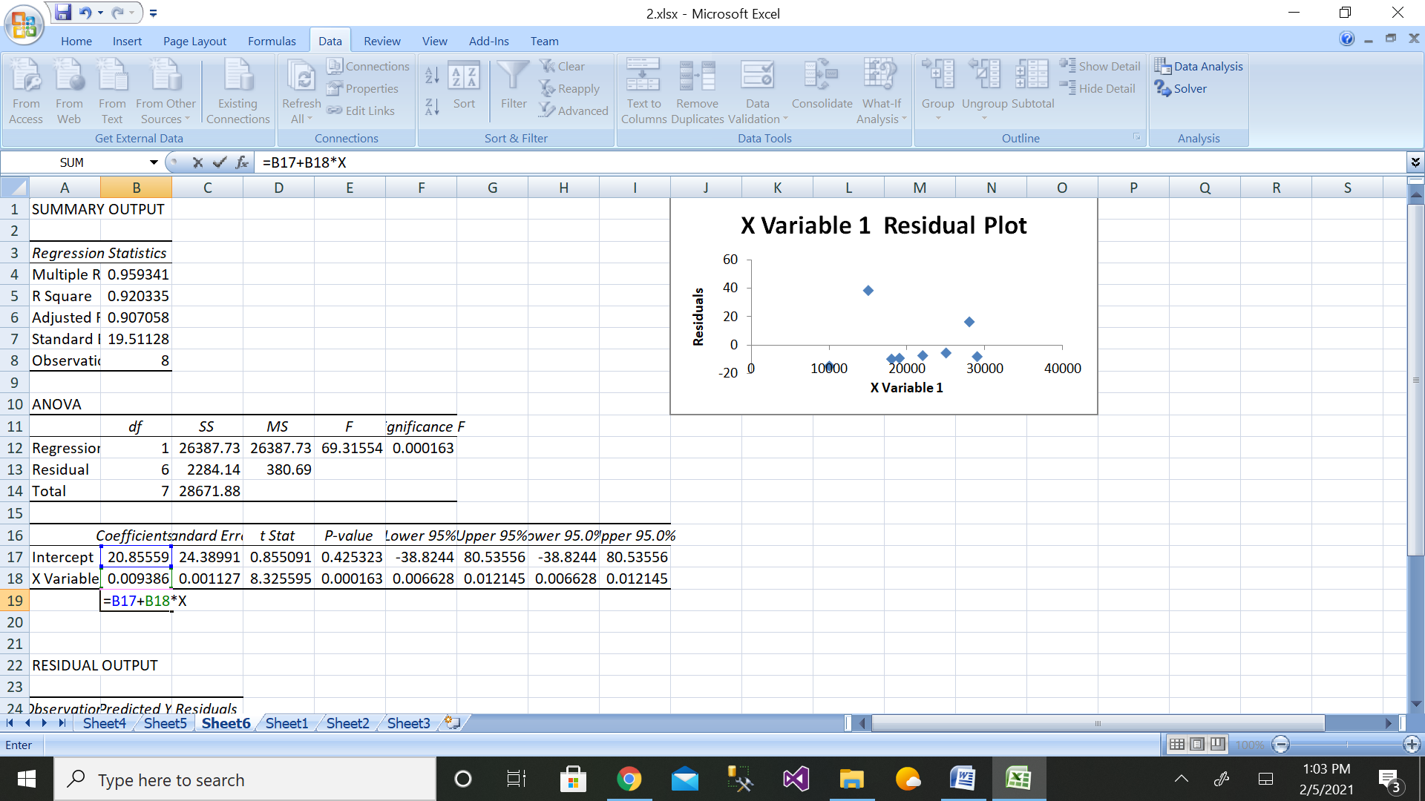

The value of sales when sales is 16500 and 17900 is

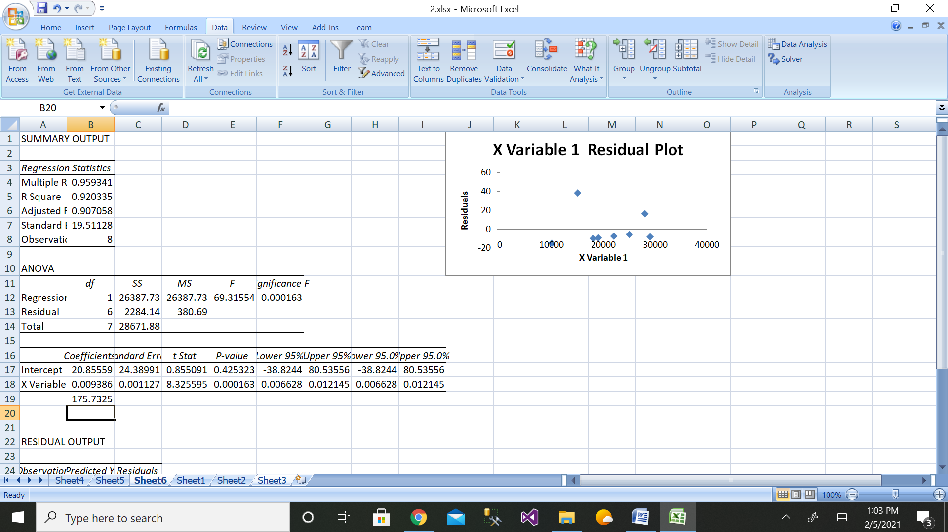

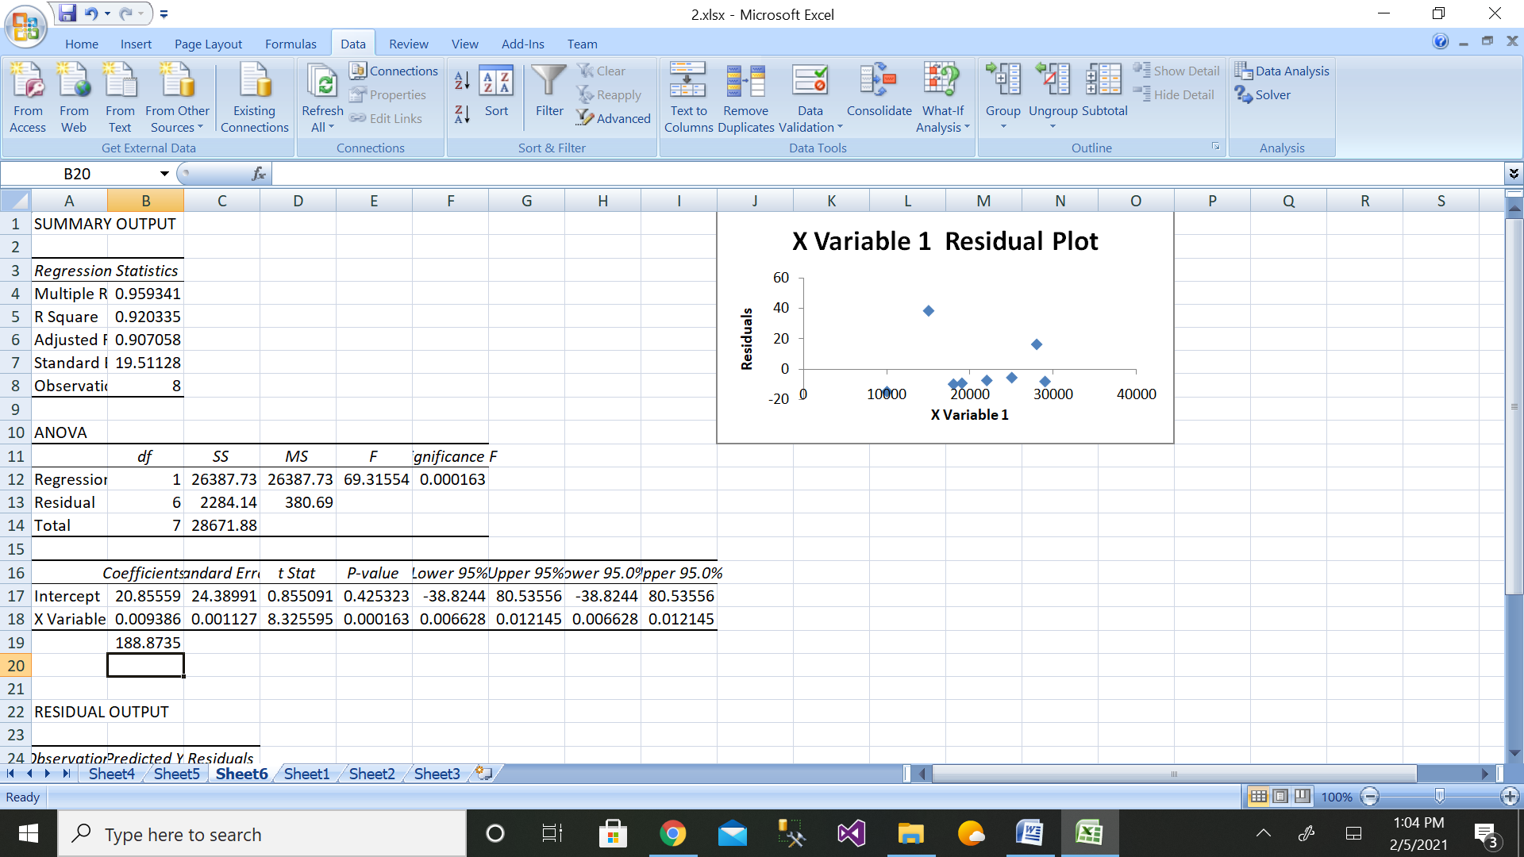

e) coefficient of determination and the coefficient of correlation

r=∑(xi−¯x)(yi−¯y ) / √∑(xi−¯x)2∑(yi−¯y)2

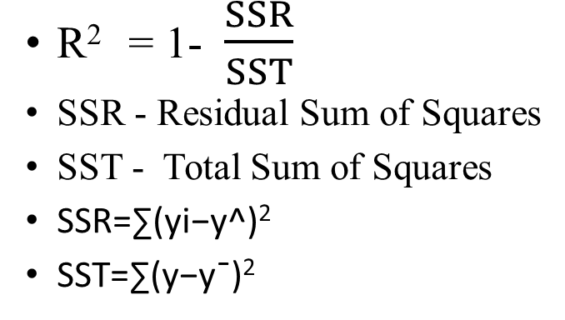

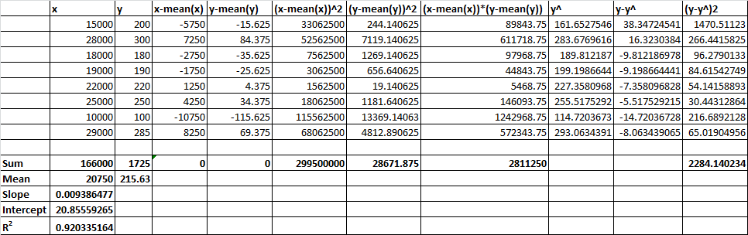

**3.Managers model costs in order to make predictions. The cost data in the data file** [**INDIRECT COSTS AND MACHINE HOURS**](https://wps.prenhall.com/wps/media/objects/973/997180/dataset_questions/indirect_costs_machine_hours.xls) **show the indirect manufacturing costs of an ice-skate manufacturer. Indirect manufacturing costs include maintenance costs and setup costs. Indirect manufacturing costs depend on the number of hours the machines are used, called machine hours. Based on the data for January to December, perform the following operations.**

1. **Plot a scatter diagram.**
2. **Determine the regression equation.**
3. **Plot the regression line (hint: use MS Excel's Add Trendline feature).**
4. **Compute the predicted indirect manufacturing costs for 300 machine hours and for 430 machine hours.**

|  |  |  |
| --- | --- | --- |
| month | no. of hours machine used | machine cost |
| Jan | 50 | 100 |
| Feb | 350 | 700 |
| Mar | 100 | 200 |
| Apr | 400 | 800 |
| May | 150 | 300 |
| Jun | 450 | 900 |
| Jul | 200 | 400 |
| Aug | 500 | 1000 |
| Sept | 250 | 500 |
| Oct | 550 | 1100 |
| Nov | 300 | 600 |
| Dec | 600 | 1200 |

1. Scatter diagram is as follows:

b) Regression equation is as follows:

y=A+Bx

c)Regression line:

d)

Step 1: Enter the data for Independent Variable x and dependent variable y as shown above 12 values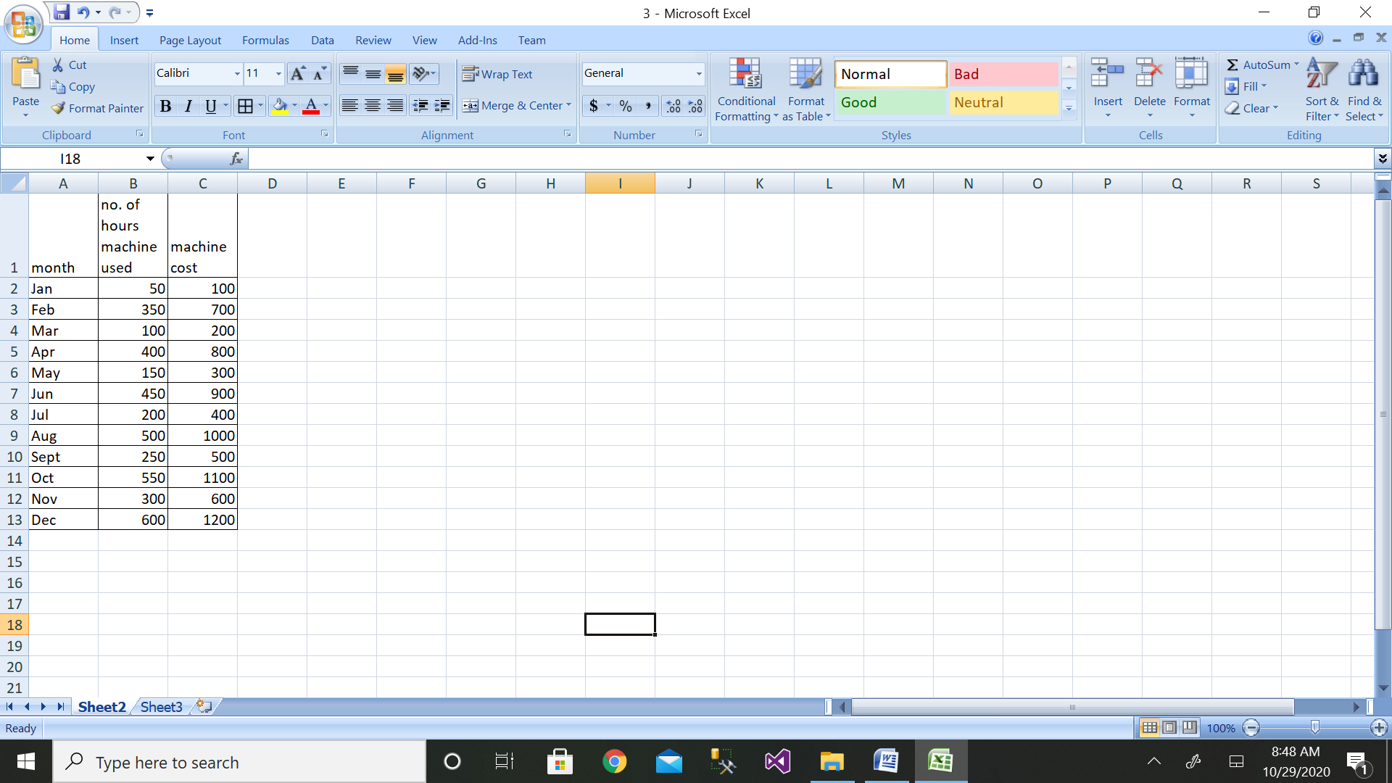

Step 2: Then click on the Data Analysis button

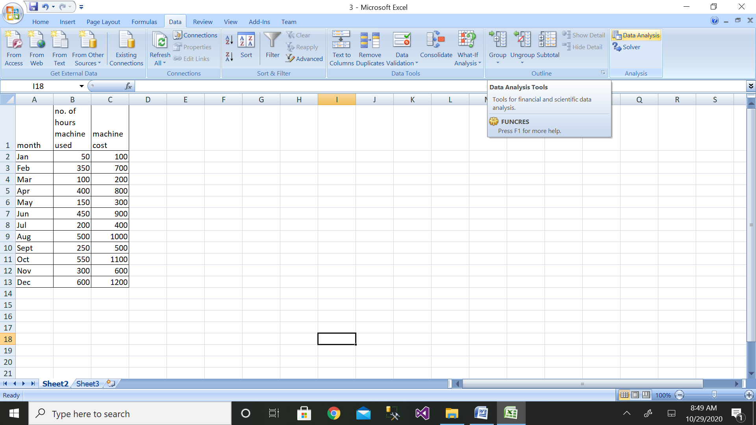

Step 3: Then click on the Regression button

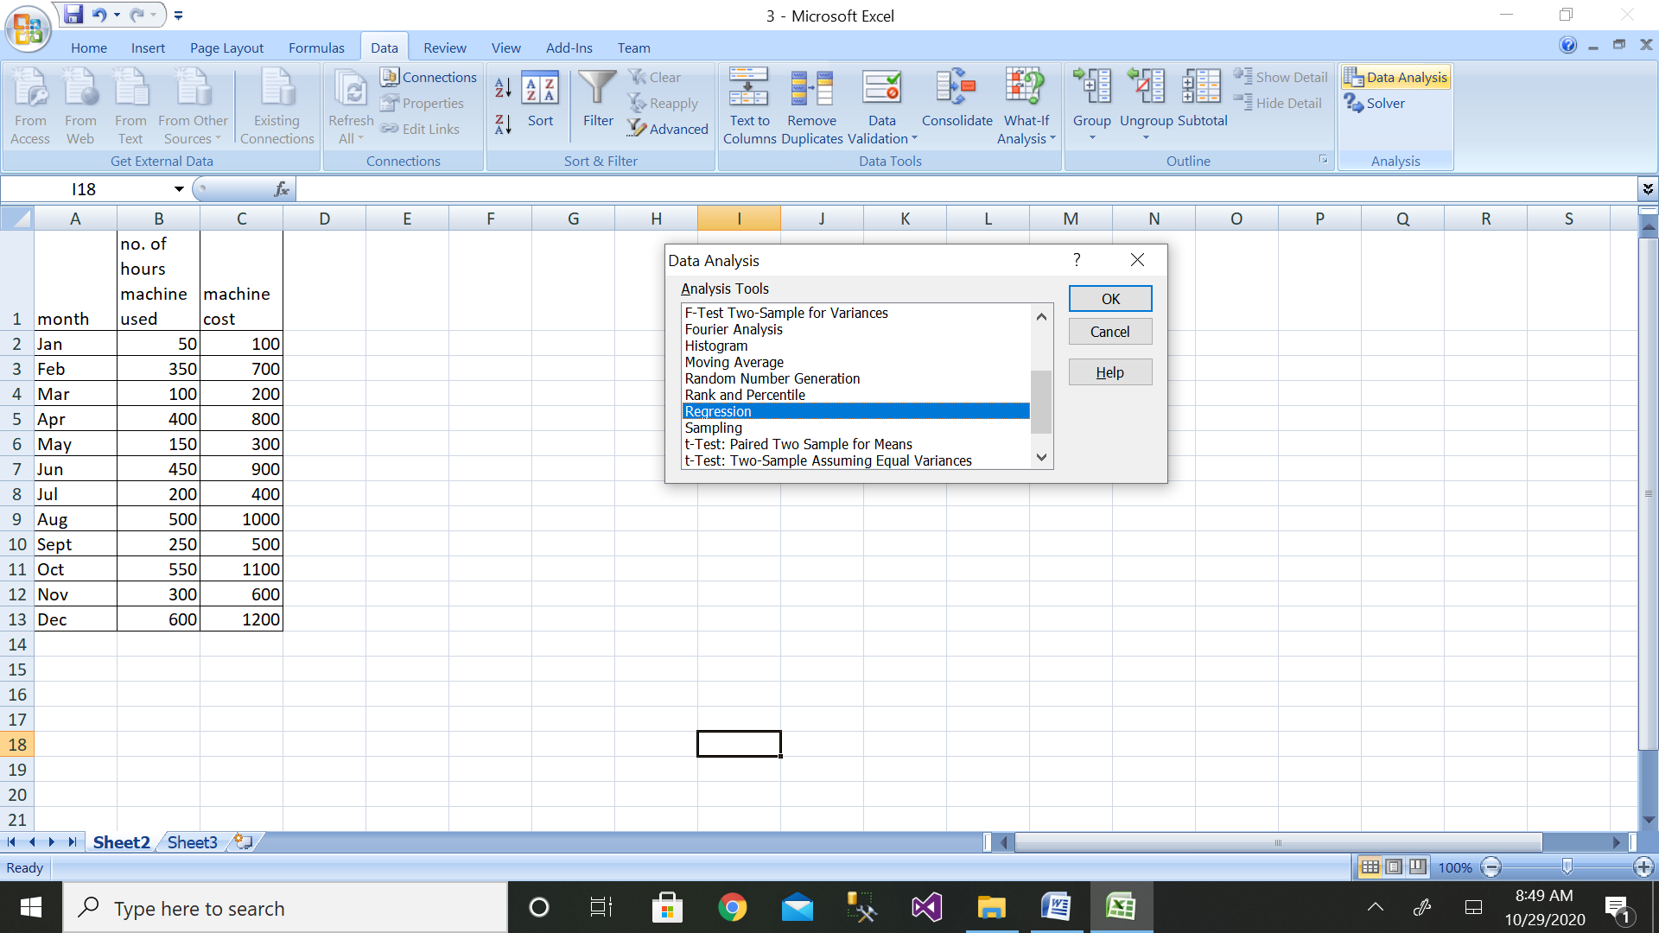

Step 4: Then select the range of dependent variable as shown above

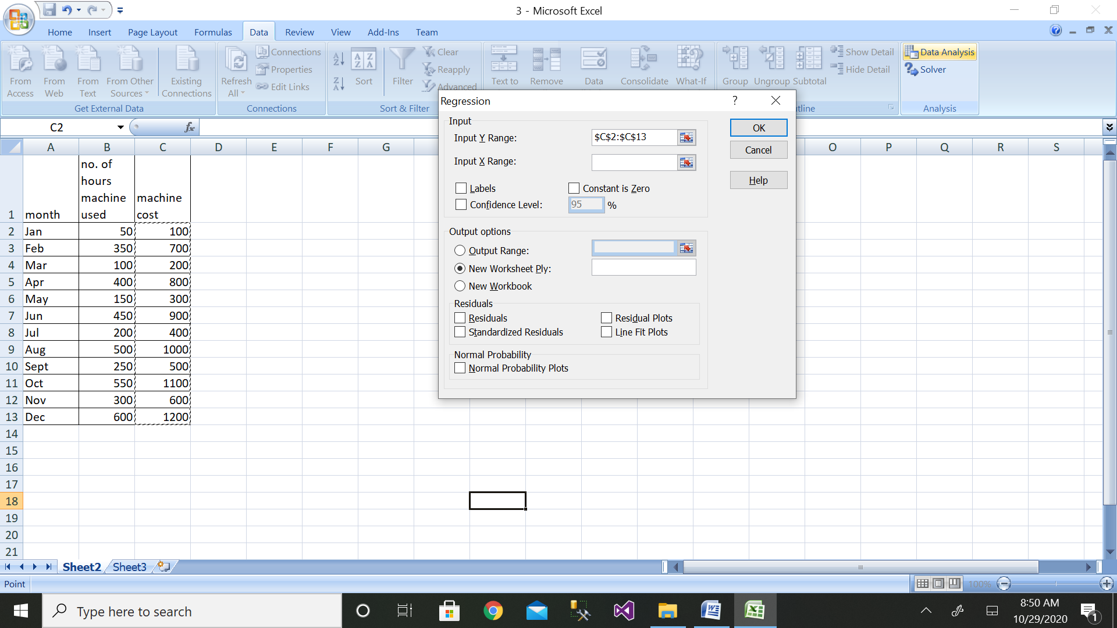

Step 5: After selecting both ranges click on ok button

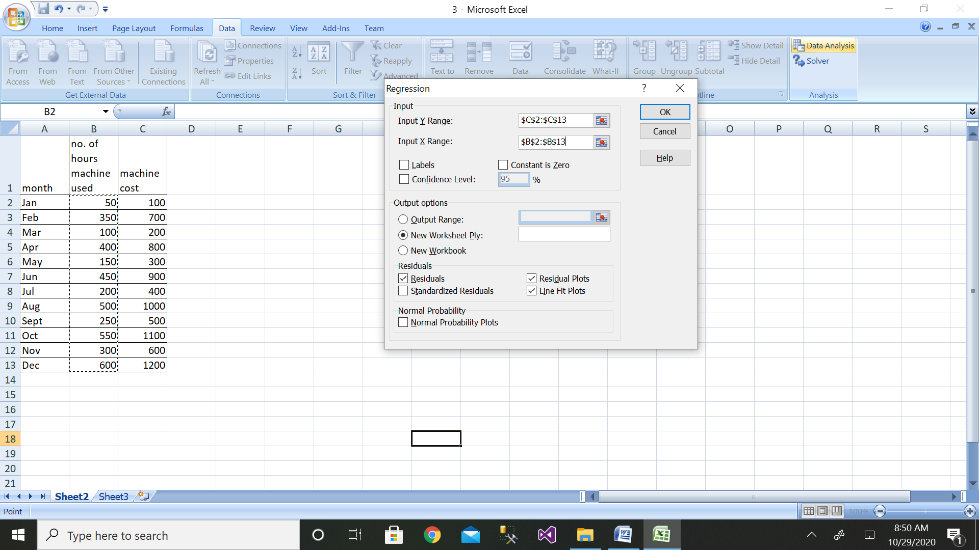

Step 6: We will get the output as shown with residual plot graph

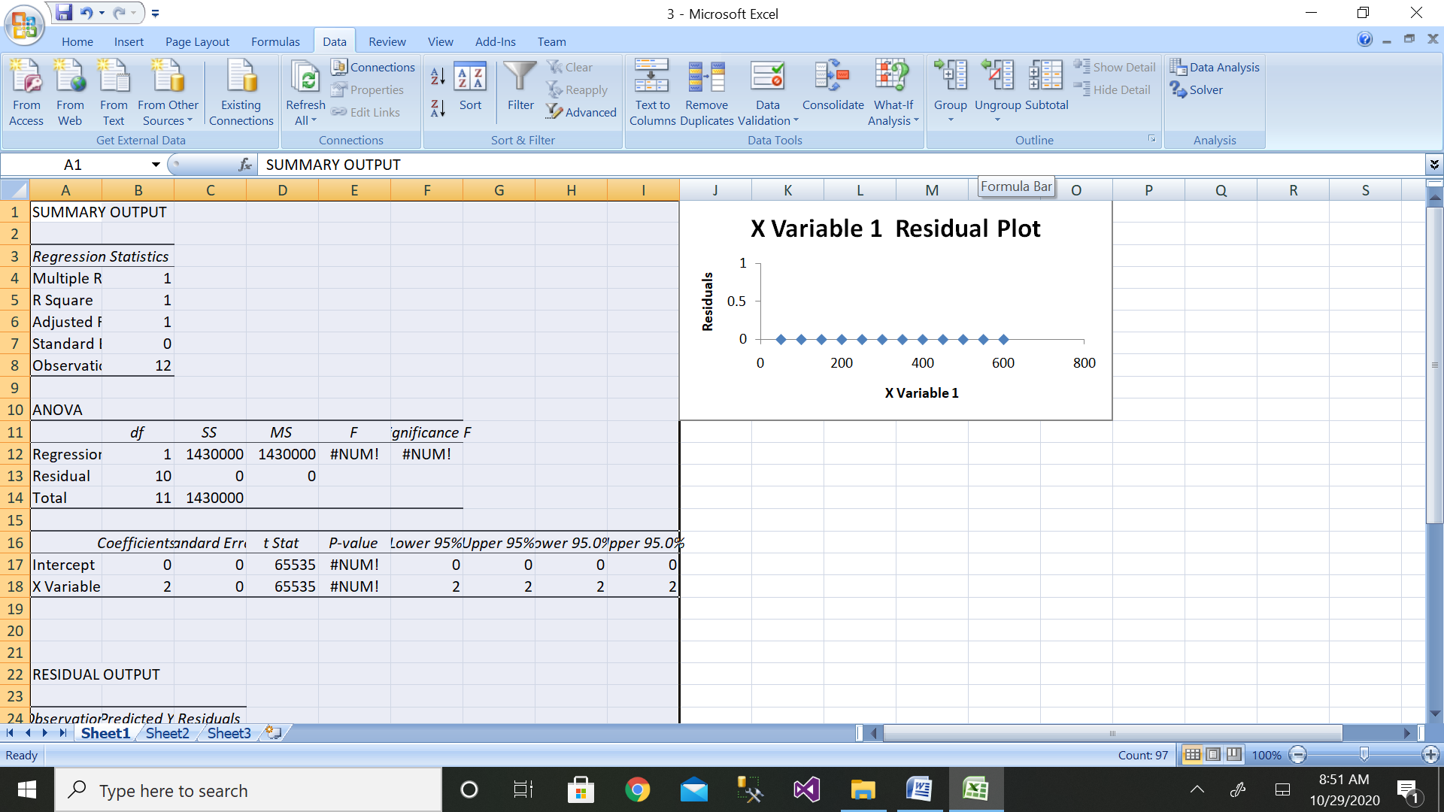

The value of cost when the machine hours are 300 and 430 are:

Y300=0+300*2

=600

Y430=0+430*2

=860

e) coefficient of determination and the coefficient of correlation

r=∑(xi−¯x)(yi−¯y ) / √∑(xi−¯x)2∑(yi−¯y)2



Manual Calculation:

|  |  |  |  |  |  |  |
| --- | --- | --- | --- | --- | --- | --- |
| machine hours(x) | cost(y) | x-mean(x) | y-mean(y) | x-mean(x)^2 | y-mean(y)^2 | x-mean(x)*y-mean(y) |
| 50 | 100 | -275 | -550 | 75625 | 302500 | 151250 |
| 350 | 700 | 25 | 50 | 625 | 2500 | 1250 |
| 100 | 200 | -225 | -450 | 50625 | 202500 | 101250 |
| 400 | 800 | 75 | 150 | 5625 | 22500 | 11250 |
| 150 | 300 | -175 | -350 | 30625 | 122500 | 61250 |
| 450 | 900 | 125 | 250 | 15625 | 62500 | 31250 |
| 200 | 400 | -125 | -250 | 15625 | 62500 | 31250 |
| 500 | 1000 | 175 | 350 | 30625 | 122500 | 61250 |
| 250 | 500 | -75 | -150 | 5625 | 22500 | 11250 |
| 550 | 1100 | 225 | 450 | 50625 | 202500 | 101250 |
| 300 | 600 | -25 | -50 | 625 | 2500 | 1250 |
| 600 | 1200 | 275 | 550 | 75625 | 302500 | 151250 |
|  |  |  |  |  |  |  |
| sum(x) | sum(y) | 0.00 | 0 | 357500.00 | 1430000 | 715000 |
| 3900 | 7800 |  |  |  |  |  |
| mean(x) | mean(y) |  |  |  |  |  |
| 325 | 650 |  |  |  |  |  |
|  |  |  |  |  |  |  |
| coefficient of regressionbyx= | ((sum(x-mean(x) *y-mean(y)) ) / (x-mean(x)^2) | 2.00 |  |  |  |  |
|  |  |  |  |  |  |  |
| calculate y intercept | A=mean(y)-byx*mean(x) |  | 0 |  |  |  |
|  |  |  |  |  |  |  |
| dependent variable=y=A+byx*x |  |  | 860 | when x=430 | When X=300 | Y=600 |
|  |  |  |  |  |  |  |
| correlation | 1 |  |  |  |  |  |
|  |  |  |  |  |  |  |
| determination=SSR |  | 160 |  |  |  |  |
|  |  |  |  |  |  |  |
|  | SSTO= | 1430000 |  |  |  |  |
|  |  |  |  |  |  |  |
| So the coeff of determination is | 0.0001119 |  |  |  |  |  |

**4. Apply multiple linear regression to predict the stock index price which is a dependent variable of a fictitious economy based on two independent / input variablesinterest rateand unemployment rate.**

|  |  |  |  |  |
| --- | --- | --- | --- | --- |
| **year** | **month** | **interest rate** | **unemployment rate** | **stock index price** |
| **2020** | **10** | **2.75** | **5.3** | **1464** |

**Solution:**

|  |  |  |  |  |
| --- | --- | --- | --- | --- |
| **year** | **month** | **interest rate** | **unemployment rate** | **stock index price** |
| 2020 | 10 | 2.75 | 5.3 | 1464 |
| 2020 | 1 | 2.5 | 5.1 | 1300 |
| 2020 | 2 | 2.4 | 5 | 1200 |
| 2020 | 3 | 2 | 4.5 | 1000 |
| 2020 | 4 | 3 | 5.5 | 1500 |
| 2020 | 6 | 3.5 | 5.7 | 1650 |
| 2020 | 8 | 2.9 | 5 | 1600 |
| 2020 | 9 | 2 | 5 | 1400 |

Step 2: Enter the data for Independent Variable x and dependent variable y as shown above 8 values

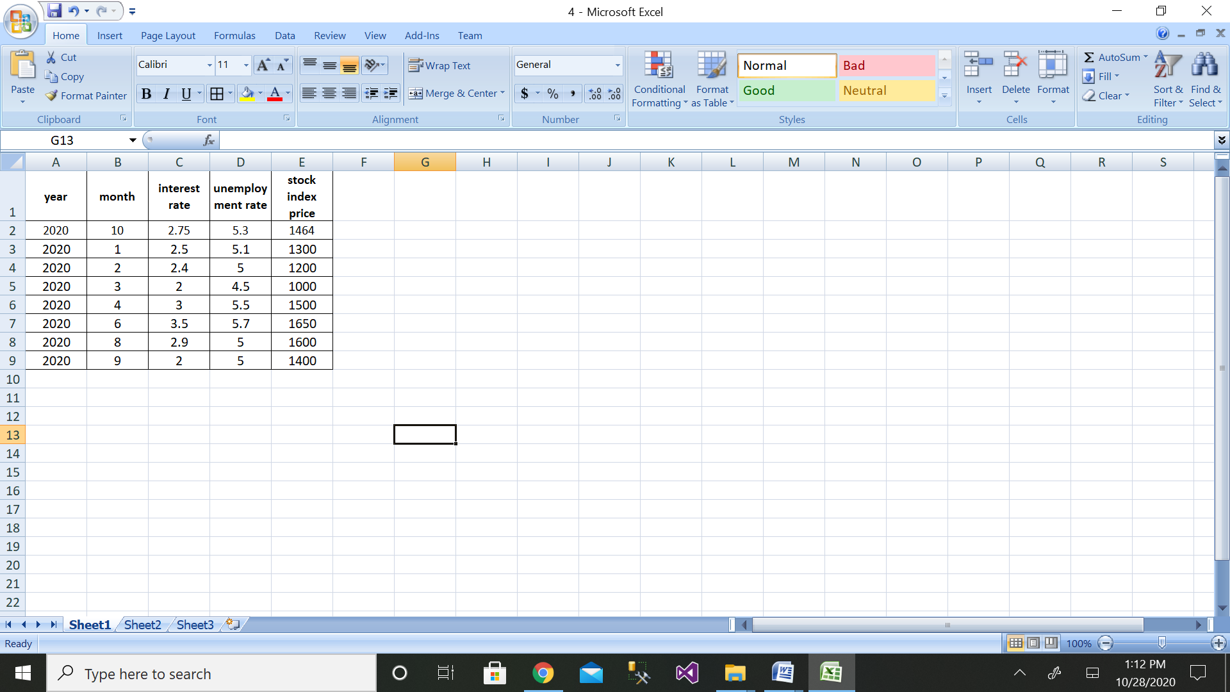

Step 3: Then click on the Data Analysis button

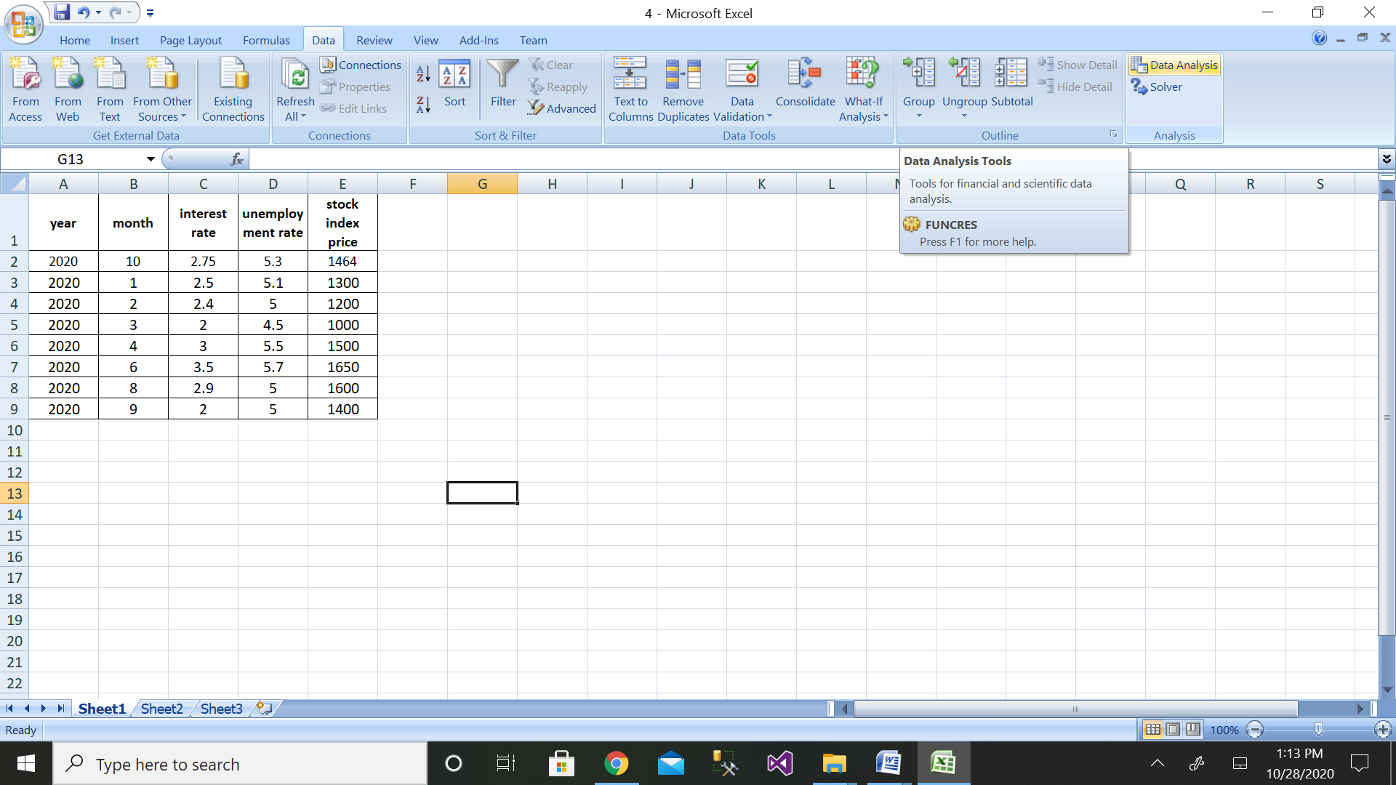

Step 4: Then click on the Regression button

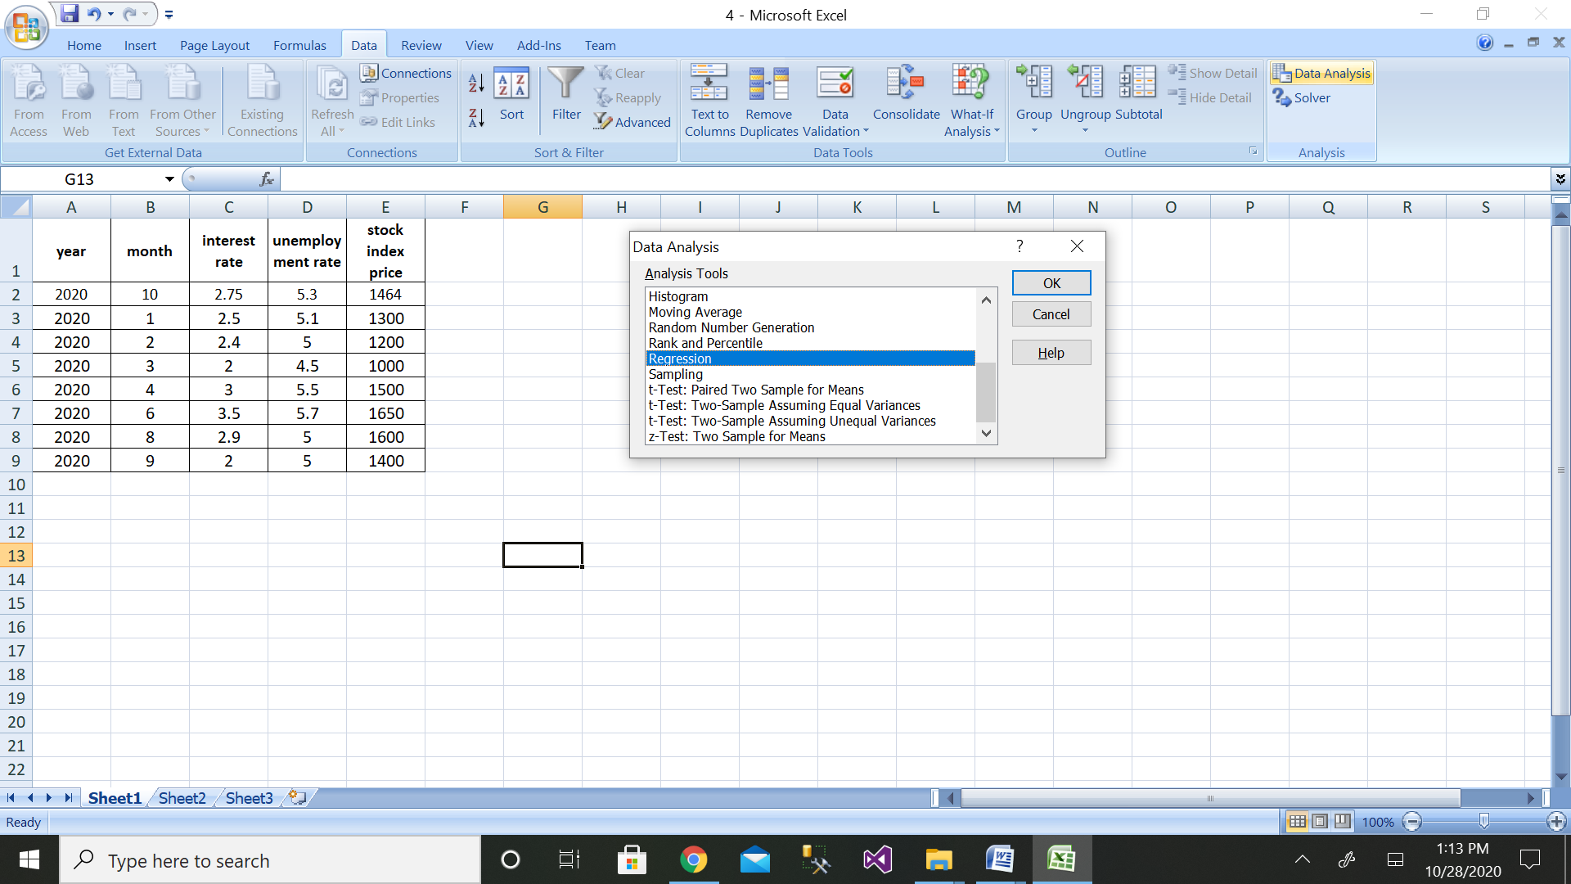

Step 5: Then select the range of dependent variable as shown above

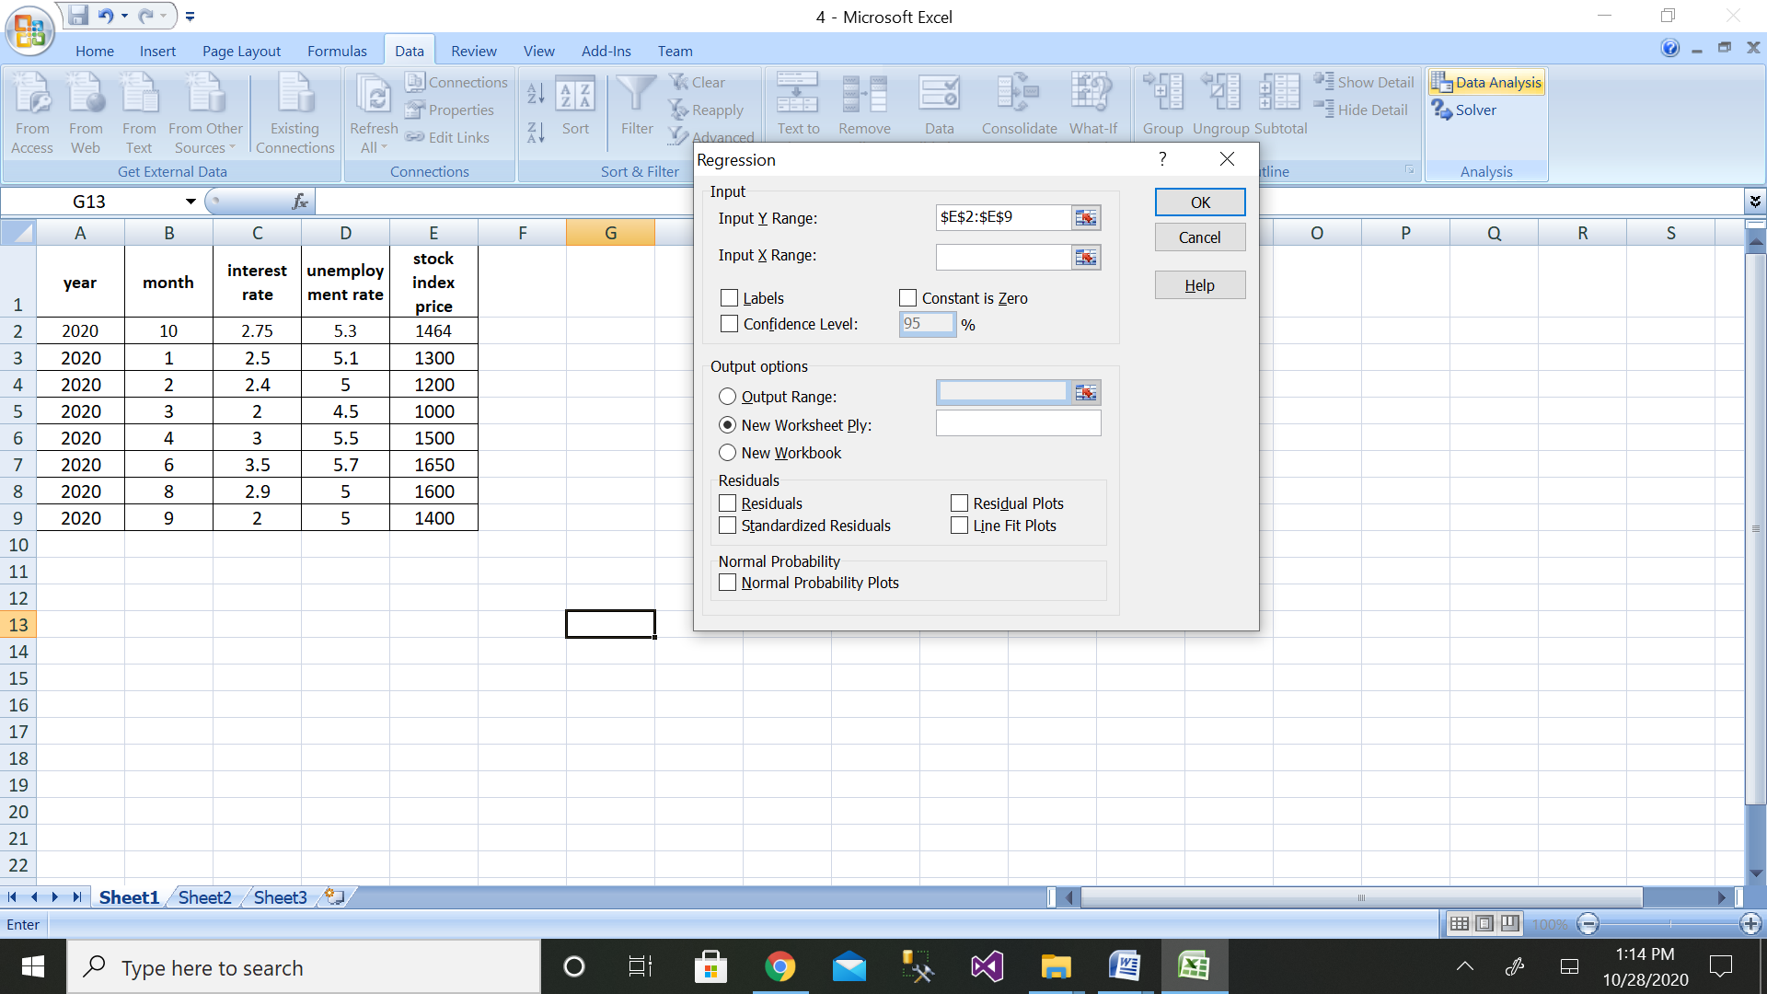

Step 6: After selecting both ranges click on ok button

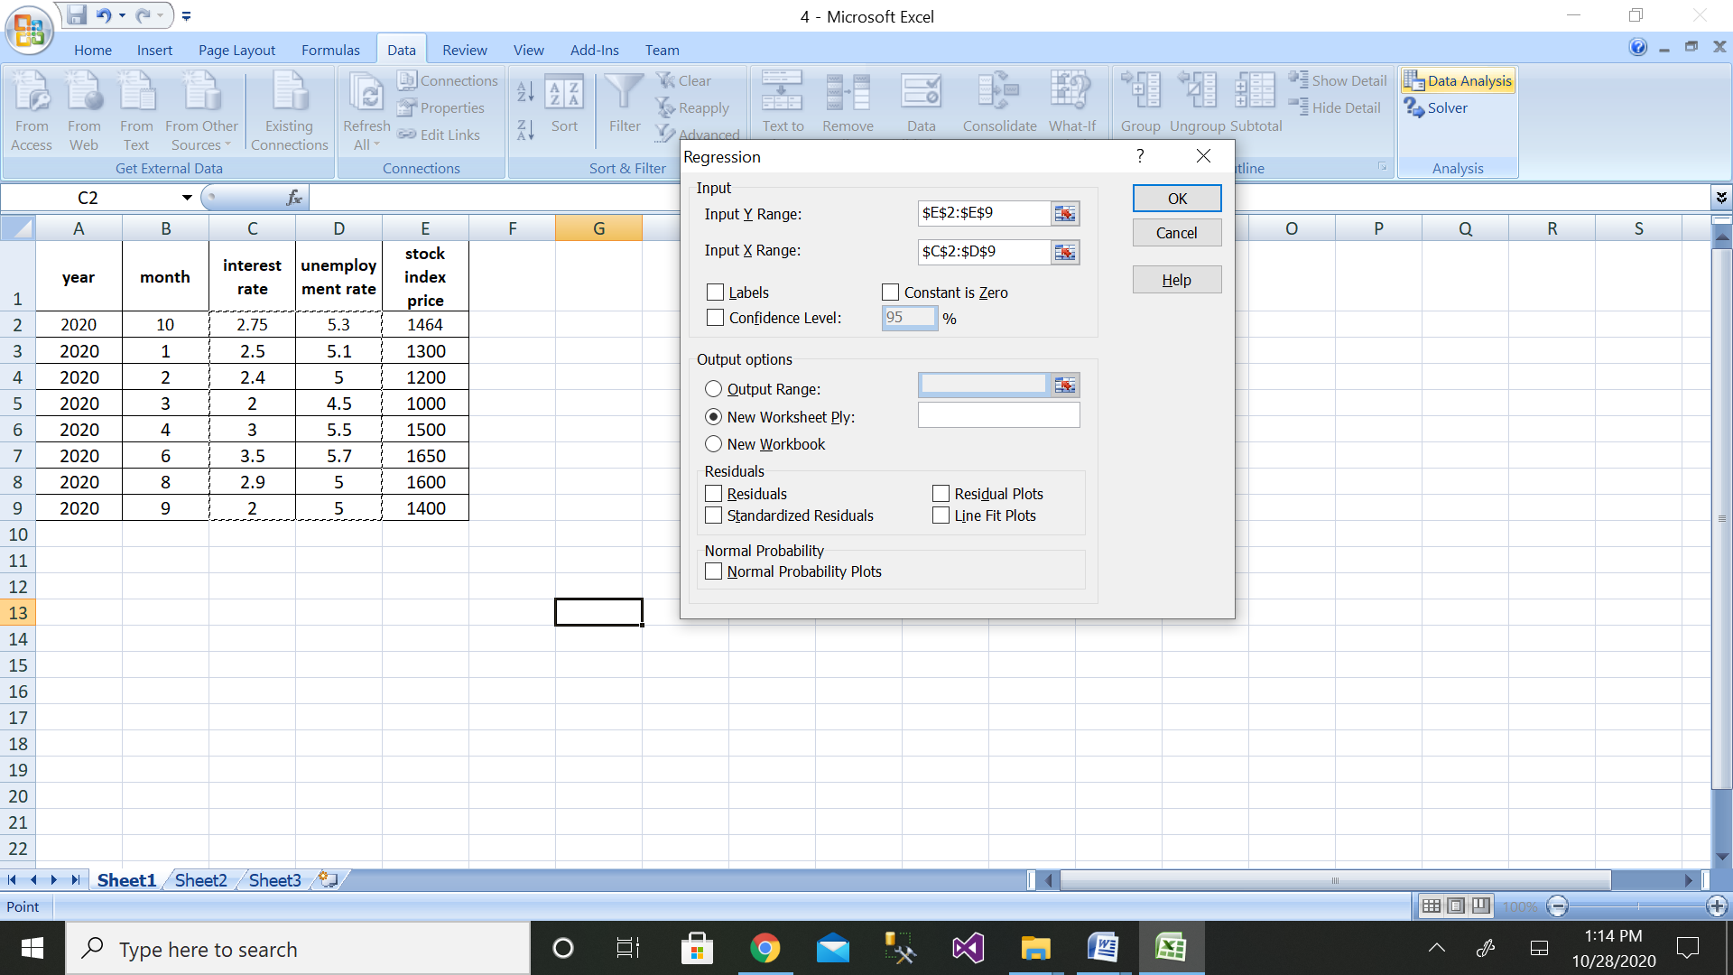

Step 7: We will get the output as shown with residual plot graph

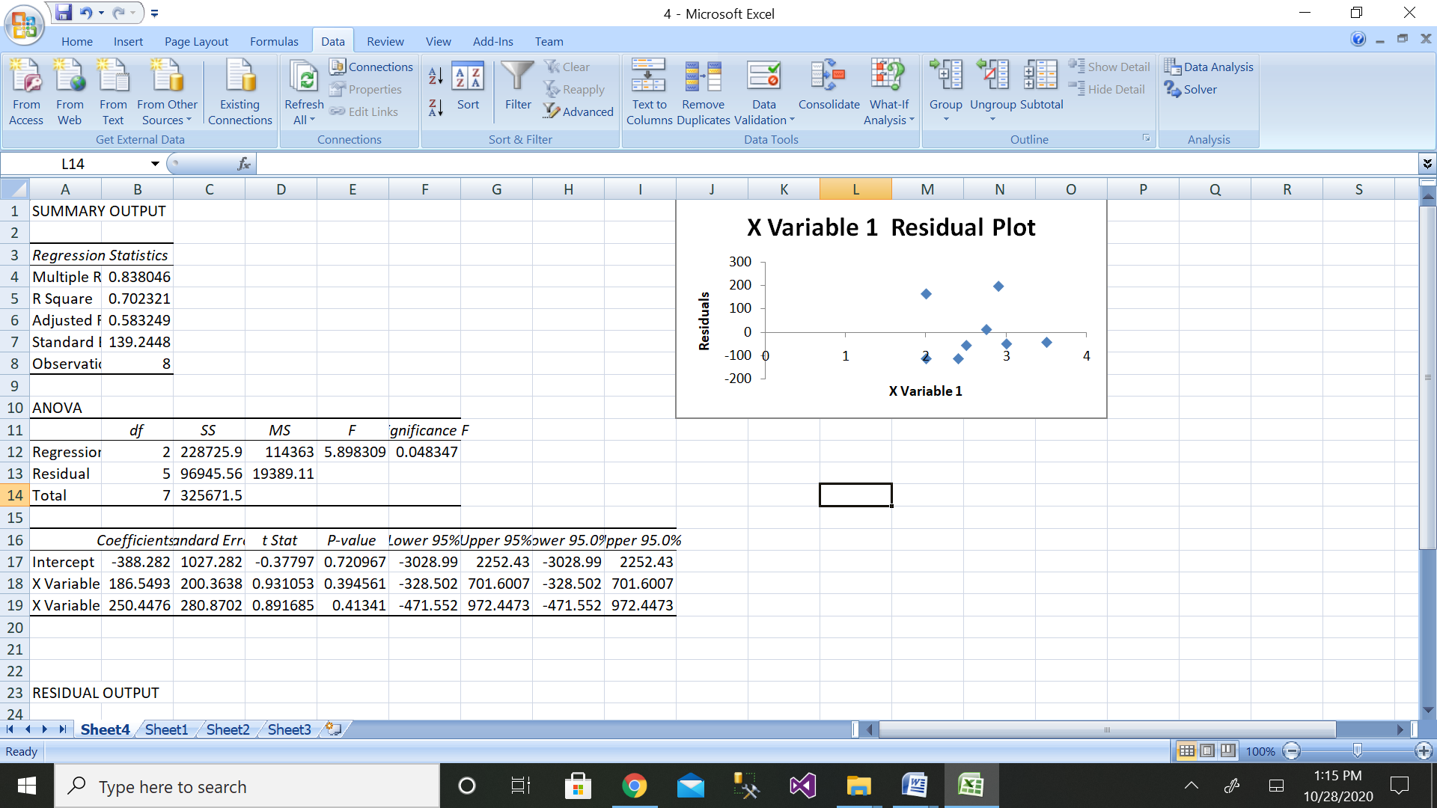

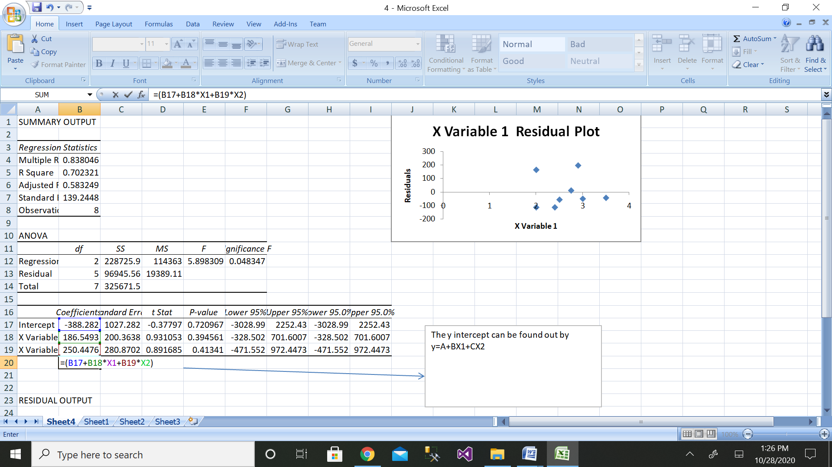

The comparison of values can be done by the above graph

1. **Calculate the total interest paid on a car loan which has been availed from HDFC bank. For example, Rs.10,00,000 has been borrowed from a bank with annual interest rate of 5.2% and the customer needs to pay every month as shown in table below. Calculate the total interest rate paid for a loan availed of Rs.10,00,000during 3 years.**

|  |  |  |
| --- | --- | --- |
| **Sl No.** | **A** | **B** |
| **1** | **Principal** | **Rs.10,00,000** |
| **2** | **Annual interest rate** | **5.20%** |
| **3** | **Year of the loan** | **3** |
| **4** | **Starting payment number** | **1** |
| **5** | **Ending payment number** | **36** |
| **6** | **total interest paid during period** | **?** |
|  |  |  |

One of the easiest ways to calculate the EMI on your loan is by using Microsoft Excel. Excel provides a simple formula for this purpose: PMT (rate, nper, pv, [fv], [type]).

PMT stands for Payment – and gives periodic loan payment or EMI value as an output. The arguments required for this function are:

* rate - The interest rate for the loan.
* nper - The total number of payments for the loan.
* pv - The present value, or the total value of all loan payments now, i.e. the outstanding loan amount.
* fv - [optional] The future value, or a cash balance you want after the last payment is made. Defaults to 0, i.e. the outstanding loan amount after all the payments are made.
* type - [optional] When payments are due. 0 = end of the period. 1 = beginning of the period. Default is 0.

When using this function, make sure that the units for rate and nper are the same. For example, if you are looking to calculate monthly EMI, the rate should be the monthly interest rate and not the annual interest rate. Let us look at an example to understand this:

Consider a loan of ₹10 lakh at 10% interest per annum for 20 years. If it is repaid in quarterly instalments:

Rate = 10%/4 per quarter

Npr = 20X4

EMI calculation in excel will be:

**= PMT(10%/4, 20*4, 10,00,000)**

|  |  |  |
| --- | --- | --- |
| Sl No. | A | B |
| 1 | Principal | Rs.10,00,000 |
| 2 | Annual interest rate | 5.20% |
| 3 | Year of the loan | 3 |
| 4 | Starting payment number | 1 |
| 5 | Ending payment number | 36 |
| 6 | total interest paid during period | ($90,541.68) |

1. **Create a supplier database of 10 records with SUPPLIER_ID as primary key, SUPPLIER_NAME, PRODUCTS, QUANTITY, ADDRESS, CITY,PHONE_NO and PINCODE, Where SUPPLIER_NAME, PRODUCTS, QUANTITY and PHONE_NO, should not be NULL.**

**Solution:**

mysql> create table supplier(SUPPLIER_ID varchar(20) , SUPPLIER_NAME varchar(20) not null, PRODUCTS varchar(20) not null, QUANTITY varchar(20) not null, ADDRESS varchar(20), CITY varchar(20), PHONE_NO integer(20) not null, PINCODE varchar(20), primary key(SUPPLIER_ID));

Query OK, 0 rows affected

mysql> insert into supplier values("111","amar","pen","20","peenya","bangalore",12345678,560057);

Query OK, 1 row affected (0.01 sec)

mysql> insert into supplier values("222","akbar","pencil","20","peenya","bangalore",12345678,560057);

Query OK, 1 row affected (0.01 sec)

mysql> insert into supplier values("333" ,"anthnony" ,"pencil" ,"20" ,"peenya" ,"bangalore" ,12345688 ,560057);

Query OK, 1 row affected (0.01 sec)

mysql> insert into supplier values("444","mahi","eraser","25","jharkand","bengal",12675688,650078);

Query OK, 1 row affected (0.01 sec)

mysql> insert into supplier values("555","manya","book","25","jharkand","bengal",12699988,650078);

Query OK, 1 row affected (0.01 sec)

mysql> insert into supplier values("666" ,"manyata" ,"sharpner" ,"25" ,"hebbal", "bangalore" ,99699988 ,650078);

Query OK, 1 row affected (0.01 sec)

mysql> insert into supplier values("888" ,"jennifer" ,"sharpner" ,"25" ,"hebbal" ,"bangalore" ,89699988 ,789098);

Query OK, 1 row affected (0.01 sec)

insert into supplier values("999","joyes","chart","25","agra","delhi",89688548,324098) ;

Query OK, 1 row affected (0.01 sec)

insert into supplier values("000","suchitra","pen pencil","25","agra","delhi",89666548,324099);

Query OK, 1 row affected (0.01 sec)

insert into supplier values("1111","hemcheth","choclate","25","bidadi","mandya",9654321,234199);

Query OK, 1 row affected (0.01 sec)

mysql> select * from supplier;

+-------------+---------------+------------+----------+----------+-----------+----------+---------+

| SUPPLIER_ID | SUPPLIER_NAME | PRODUCTS | QUANTITY | ADDRESS | CITY | PHONE_NO | PINCODE |

+-------------+---------------+------------+----------+----------+-----------+----------+---------+

| 000 | suchitra | pen pencil | 25 | agra | delhi | 89666548 | 324099 |

| 111 | amar | pen | 20 | peenya | bangalore | 12345678 | 560057 |

| 1111 | hemcheth | choclate | 25 | bidadi | mandya | 9654321 | 234199 |

| 222 | akbar | pencil | 20 | peenya | bangalore | 12345678 | 560057 |

| 333 | anthnony | pencil | 20 | peenya | bangalore | 12345688 | 560057 |

| 444 | mahi | eraser | 25 | jharkand | bengal | 12675688 | 650078 |

| 555 | manya | book | 25 | jharkand | bengal | 12699988 | 650078 |

| 666 | manyata | sharpner | 25 | hebbal | bangalore | 99699988 | 650078 |

| 888 | jennifer | sharpner | 25 | hebbal | bangalore | 89699988 | 789098 |

| 999 | joyes | chart | 25 | agra | delhi | 89688548 | 324098 |

+-------------+---------------+------------+----------+----------+-----------+----------+---------+

10 rows in set (0.00 sec)

1. **Create the customer database of a big Market with CUSTOMER_IDas primary key,CUSTOMER_NAME, PHONE_NO, EMAIL_ID, ADDRESS, CITY and PIN_CODE. Store at least twenty customers details where CUSTOMER_NAME and PHONE_NO are mandatory and display the customer data in alphabetical order.**

mysql> create table big_market(CUSTOMER_ID varchar(20), CUSTOMER_NAME varchar(20) not null, PHONE_NO integer(30) not null, EMAIL varchar(20),ADDRESS varchar(20), CITY varchar(20),PINCODE integer(20),primary key(CUSTOMER_ID));

Query OK, 0 rows affected(0.07 sec)

insert into big_market values("111","Geetha",7019231,"geetha.b@reva.edu.in","peenya", "bangalore" ,560057);

Query OK, 1 row affected (0.02 sec)

mysql> insert into big_market values("2","HEM",23719231,"hem@reva.edu.in","khalli", "bangalore",560035);

Query OK, 1 row affected (0.01 sec)

mysql> insert into big_market values("3","nagesh",23719231,"nagi@reva.edu.in","khalli", "bangalore" ,560035);

Query OK, 1 row affected (0.01 sec)

mysql> insert into big_market values("4","akki",23732731,"akki@reva.edu.in","khalli","bangalore", 560035);

Query OK, 1 row affected (0.01 sec)

mysql> insert into big_market values("5","vinay",87732731,"vinu@reva.edu.in","khalli","bangalore", 560035);

Query OK, 1 row affected (0.01 sec)

mysql> insert into big_market values("6","shankar",87732731,"shankar@reva.edu.in","khalli", "bangalore", 560035);

Query OK, 1 row affected (0.01 sec)

mysql> insert into big_market values("7","kali",56732731,"kal@reva.edu.in","dhalli", "bangalore",560067);

Query OK, 1 row affected (0.01 sec)

mysql> insert into big_market values("8","chetan",70982731,"chethu@reva.edu.in","dhalli", "bangalore",560067);

Query OK, 1 row affected (0.01 sec)

mysql> insert into big_market values("9","giri",90882731,"giri@reva.edu.in","dhalli", "bangalore",560057);

Query OK, 1 row affected (0.01 sec)

mysql> insert into big_market values("10","lat",090882731,"lat@reva.edu.in","dhalli", "bangalore",560057);

Query OK, 1 row affected (0.01 sec)

mysql> insert into big_market values("11","gowrish",99882731,"gowri@reva.edu.in","dhalli", "bangalore",560057);

Query OK, 1 row affected (0.01 sec)

mysql> insert into big_market values("12","suri",99882731,"suri@reva.edu.in","dhalli", "bangalore",560057);

Query OK, 1 row affected (0.01 sec)

mysql> insert into big_market values("13","kat",99800831,"kat@reva.edu.in","dhalli", "bangalore",560057);

Query OK, 1 row affected (0.01 sec)

mysql> insert into big_market values("14","shalini",99776831,"shalini@reva.edu.in","mhalli", "bangalore",560057);

Query OK, 1 row affected (0.01 sec)

mysql> insert into big_market values("15","thiru",900776831,"thiru@reva.edu.in","mhalli", "bangalore",560057);

Query OK, 1 row affected (0.01 sec)

mysql> insert into big_market values("16","archana",987776831,"archana@reva.edu.in","hennu", "bangalore",560407);

Query OK, 1 row affected (0.01 sec)

mysql> insert into big_market values("17","anirudh",886776831,"ani@reva.edu.in","hennu", "bangalore",560407);

Query OK, 1 row affected (0.01 sec)

mysql> insert into big_market values("18","aman",776776831,"aman@reva.edu.in","kannur", "bangalore",509907);

Query OK, 1 row affected (0.01 sec)

mysql> insert into big_market values("19","akash",776776831,"akash@reva.edu.in","kannur" ,"bangalore", 509907);

Query OK, 1 row affected (0.01 sec)

mysql> insert into big_market values("20","santosh",776776831,"sant@reva.edu.in","kannur", "bangalore" , 509907);

Query OK, 1 row affected (0.01 sec)

mysql> select * from big_market;

+-------------+---------------+-----------+----------------------+---------+-----------+---------+

| CUSTOMER_ID | CUSTOMER_NAME | PHONE_NO | EMAIL | ADDRESS | CITY | PINCODE |

+-------------+---------------+-----------+----------------------+---------+-----------+---------+

| 10 | lat | 90882731 | lat@reva.edu.in | dhalli | bangalore | 560057 |

| 11 | gowrish | 99882731 | gowri@reva.edu.in | dhalli | bangalore | 560057 |

| 111 | Geetha | 7019231 | geetha.b@reva.edu.in | peenya | bangalore | 560057 |

| 12 | suri | 99882731 | suri@reva.edu.in | dhalli | bangalore | 560057 |

| 13 | kat | 99800831 | kat@reva.edu.in | dhalli | bangalore | 560057 |

| 14 | shalini | 99776831 | shalini@reva.edu.in | mhalli | bangalore | 560057 |

| 15 | thiru | 900776831 | thiru@reva.edu.in | mhalli | bangalore | 560057 |

| 16 | archana | 987776831 | archana@reva.edu.in | hennu | bangalore | 560407 |

| 17 | anirudh | 886776831 | ani@reva.edu.in | hennu | bangalore | 560407 |

| 18 | aman | 776776831 | aman@reva.edu.in | kannur | bangalore | 509907 |

| 19 | akash | 776776831 | akash@reva.edu.in | kannur | bangalore | 509907 |

| 2 | HEM | 23719231 | hem@reva.edu.in | khalli | bangalore | 560035 |

| 20 | santosh | 776776831 | sant@reva.edu.in | kannur | bangalore | 509907 |

| 3 | nagesh | 23719231 | nagi@reva.edu.in | khalli | bangalore | 560035 |

| 4 | akki | 23732731 | akki@reva.edu.in | khalli | bangalore | 560035 |

| 5 | vinay | 87732731 | vinu@reva.edu.in | khalli | bangalore | 560035 |

| 6 | shankar | 87732731 | shankar@reva.edu.in | khalli | bangalore | 560035 |

| 7 | kali | 56732731 | kal@reva.edu.in | dhalli | bangalore | 560067 |

| 8 | chetan | 70982731 | chethu@reva.edu.in | dhalli | bangalore | 560067 |

| 9 | giri | 90882731 | giri@reva.edu.in | dhalli | bangalore | 560057 |

+-------------+---------------+-----------+----------------------+---------+-----------+---------+

20 **rows in set (0.00 sec)**

**To arrange in alphabetical order;**

mysql> select * from big_market order by CUSTOMER_NAME;

+-------------+---------------+-----------+----------------------+---------+-----------+---------+

| CUSTOMER_ID | CUSTOMER_NAME | PHONE_NO | EMAIL | ADDRESS | CITY | PINCODE |

+-------------+---------------+-----------+----------------------+---------+-----------+---------+

| 19 | akash | 776776831 | akash@reva.edu.in | kannur | bangalore | 509907 |

| 4 | akki | 23732731 | akki@reva.edu.in | khalli | bangalore | 560035 |

| 18 | aman | 776776831 | aman@reva.edu.in | kannur | bangalore | 509907 |

| 17 | anirudh | 886776831 | ani@reva.edu.in | hennu | bangalore | 560407 |

| 16 | archana | 987776831 | archana@reva.edu.in | hennu | bangalore | 560407 |

| 8 | chetan | 70982731 | chethu@reva.edu.in | dhalli | bangalore | 560067 |

| 111 | Geetha | 7019231 | geetha.b@reva.edu.in | peenya | bangalore | 560057 |

| 9 | giri | 90882731 | giri@reva.edu.in | dhalli | bangalore | 560057 |

| 11 | gowrish | 99882731 | gowri@reva.edu.in | dhalli | bangalore | 560057 |

| 2 | HEM | 23719231 | hem@reva.edu.in | khalli | bangalore | 560035 |

| 7 | kali | 56732731 | kal@reva.edu.in | dhalli | bangalore | 560067 |

| 13 | kat | 99800831 | kat@reva.edu.in | dhalli | bangalore | 560057 |

| 10 | lat | 90882731 | lat@reva.edu.in | dhalli | bangalore | 560057 |

| 3 | nagesh | 23719231 | nagi@reva.edu.in | khalli | bangalore | 560035 |

| 20 | santosh | 776776831 | sant@reva.edu.in | kannur | bangalore | 509907 |

| 14 | shalini | 99776831 | shalini@reva.edu.in | mhalli | bangalore | 560057 |

| 6 | shankar | 87732731 | shankar@reva.edu.in | khalli | bangalore | 560035 |

| 12 | suri | 99882731 | suri@reva.edu.in | dhalli | bangalore | 560057 |

| 15 | thiru | 900776831 | thiru@reva.edu.in | mhalli | bangalore | 560057 |

| 5 | vinay | 87732731 | vinu@reva.edu.in | khalli | bangalore | 560035 |

+-------------+---------------+-----------+----------------------+---------+-----------+---------+

20 rows in set (0.01 sec)

1. **Apply linear regression to find the weather (temperature) of a city with the amount of rain in centimeters. Create your own database with following details.**

|  |  |  |
| --- | --- | --- |
| **CITY** | **Temperature in Centigrade** | **Rain in Centimeters** |
|  |  |  |

**Solution:**

Step 1: Height data have been taken from dataset.

|  |  |
| --- | --- |
| Temperature in centigrade | Rain in centimeters |
| 23 | 163 |
| 25 | 158 |
| 22 | 167 |
| 18 | 170 |
| 20 | 160 |
| 15 | 180 |
| 16 | 175 |
| 17 | 172 |

Step 2: Enter the data for Independent Variable x and dependent variable y as shown above 11 values

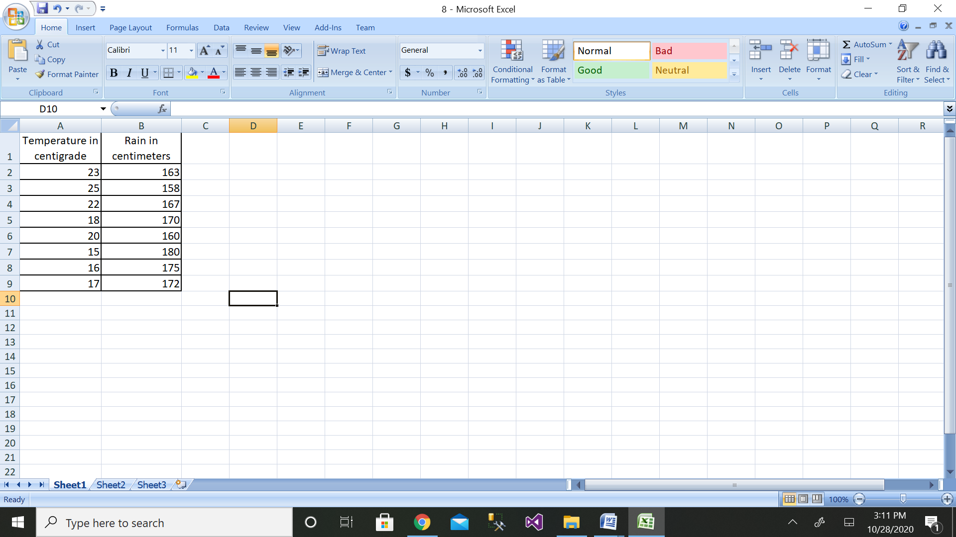

Step 3: Then click on the Data Analysis button

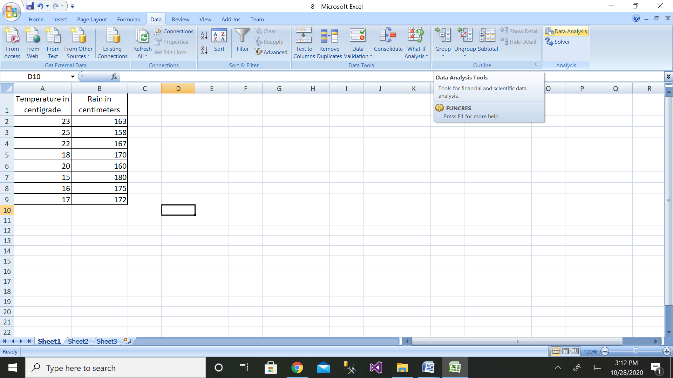

Step 4: Then click on the Regression button

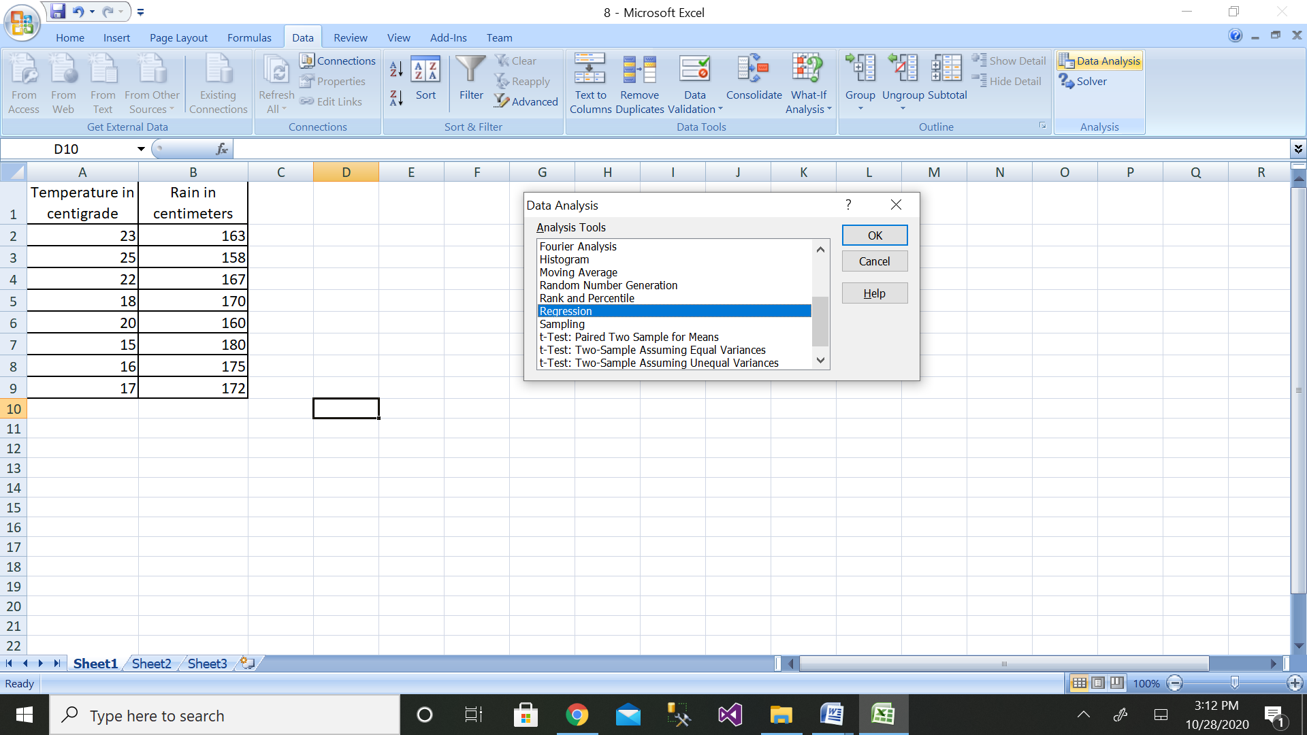

Step 5: Then select the range of dependent variable as shown above

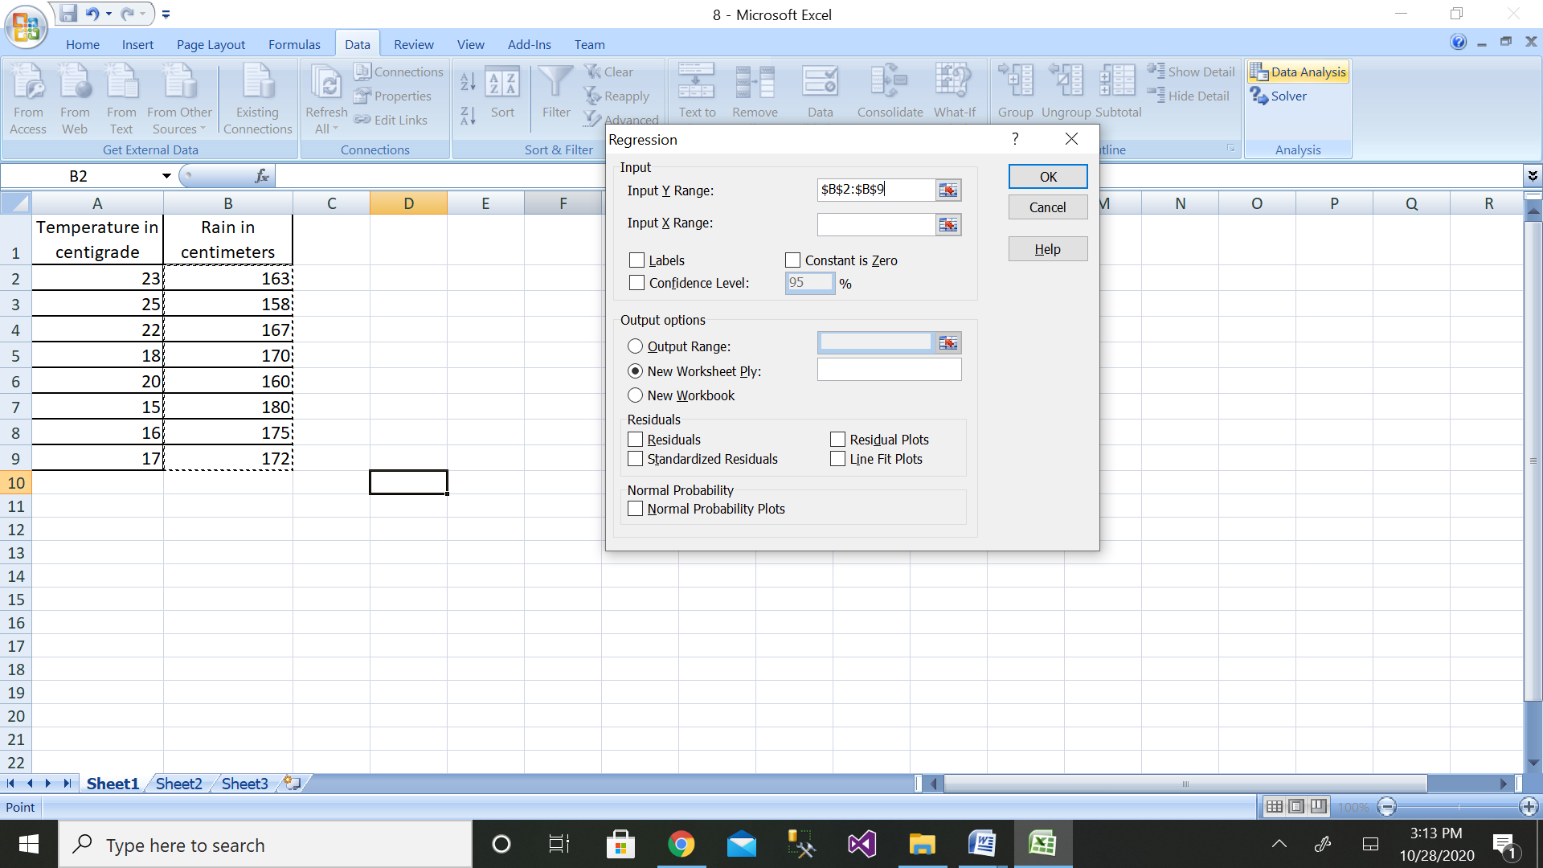

Step 6: After selecting both ranges click on ok button

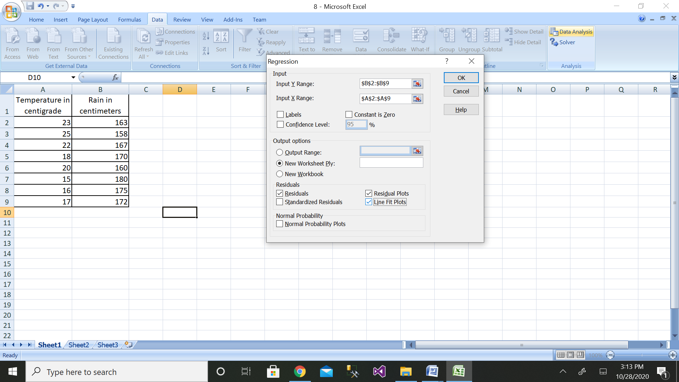

Step 7: We will get the output as shown with residual plot graph

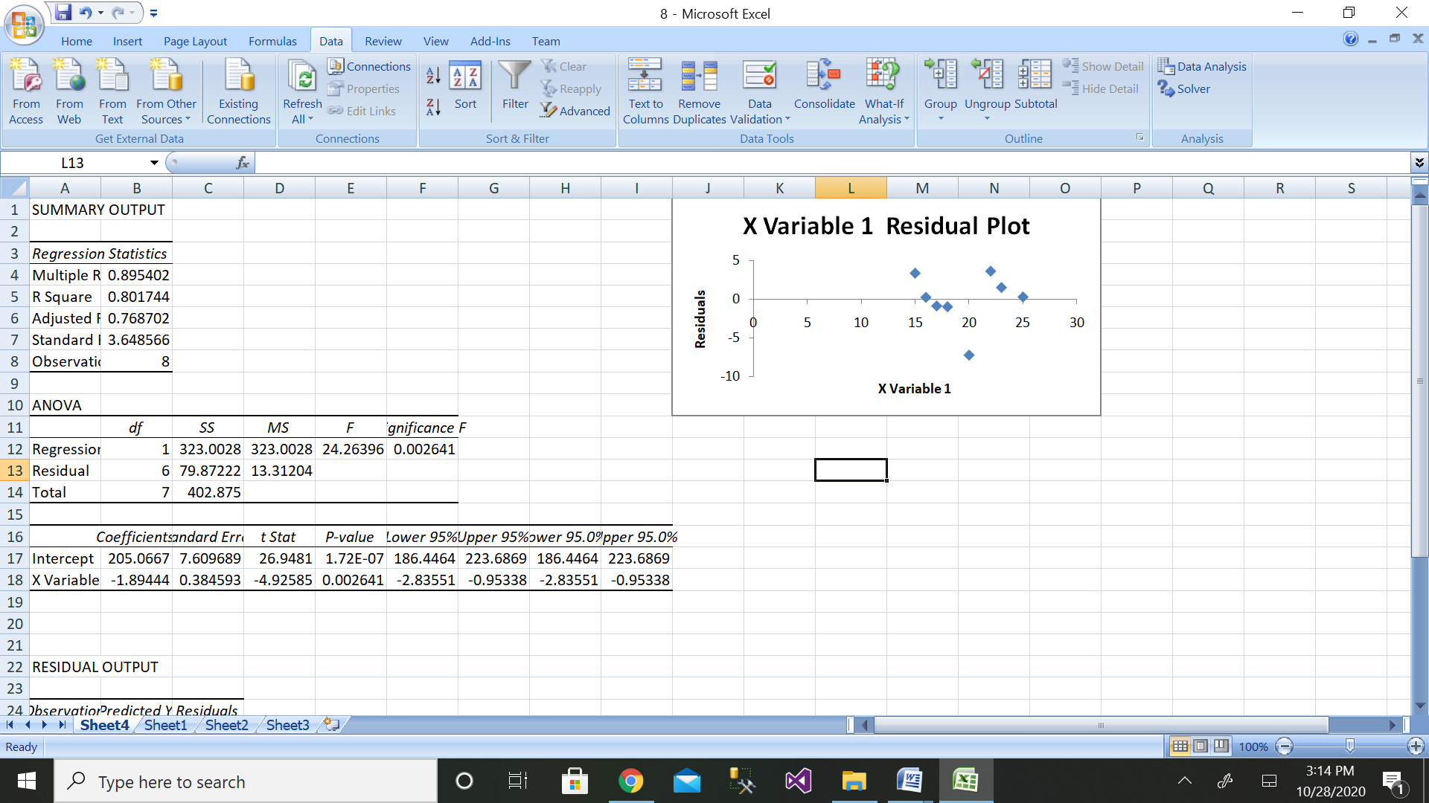

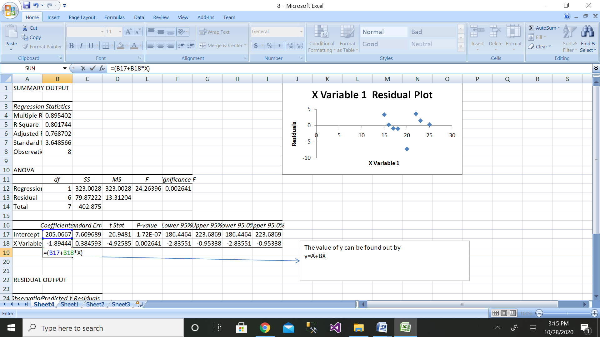

The comparison of values can be done by the above graph.

**9. Use the linear regression technique to compare the age of humans with the amount of sleep in hours.**

|  |  |  |
| --- | --- | --- |
| **Name** | **Age in Years** | **Sleep in hours** |

**Create your own database with above details.**

**Solution:**

Step 1: Height data have been taken from dataset.

|  |  |  |
| --- | --- | --- |
| Name | Age in Years | Sleep in hours |
| Ashwini | 50 | 5 |
| Arthi | 25 | 11 |
| Afreen | 29 | 9 |
| Aman | 18 | 10 |
| Hem | 10 | 13 |
| Chetan | 9 | 14 |
| Gouri | 60 | 4 |
| Ameen | 17 | 12 |

Step 2: Enter the data for Independent Variable x and dependent variable y as shown above 11 values

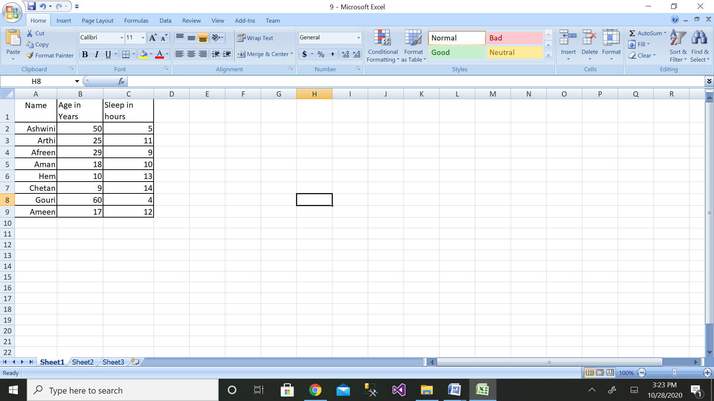

Step 3: Then click on the Data Analysis button

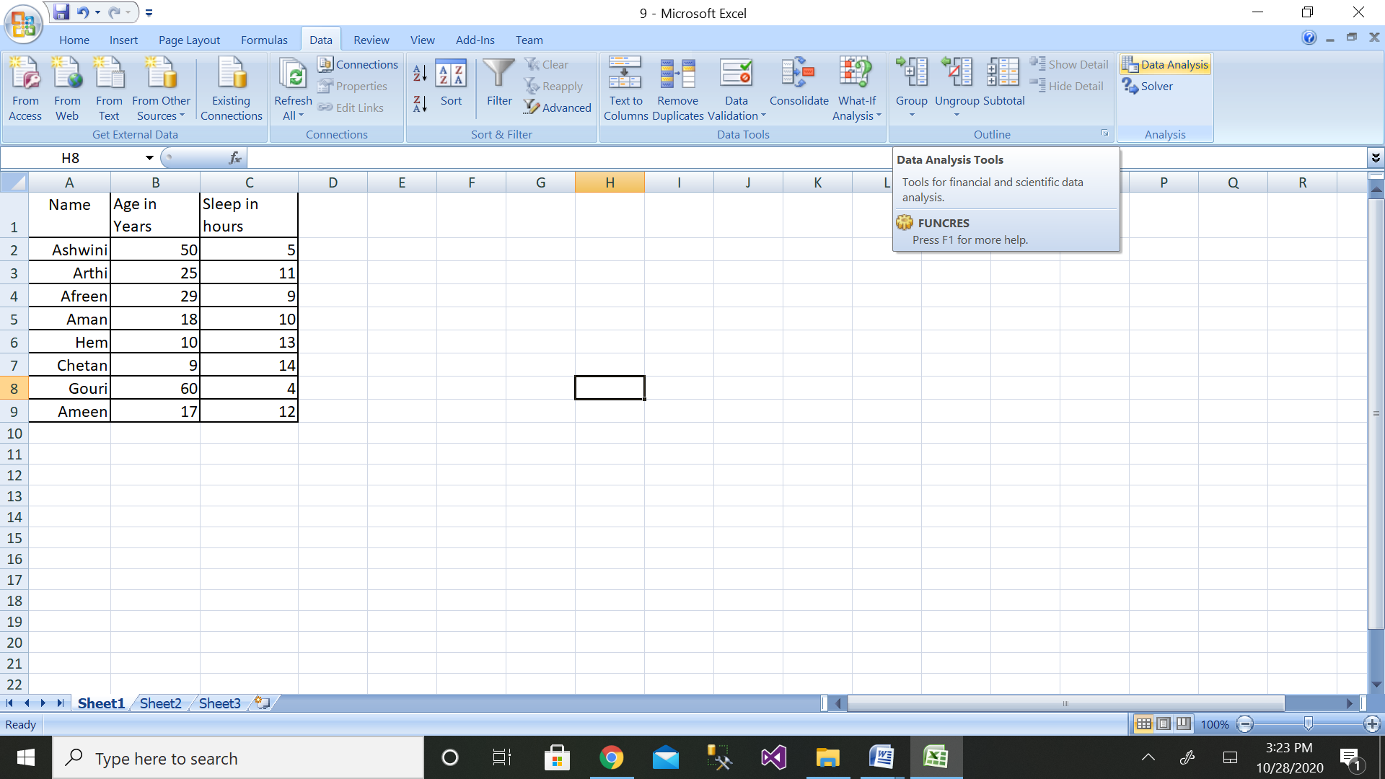

Step 4: Then click on the Regression button

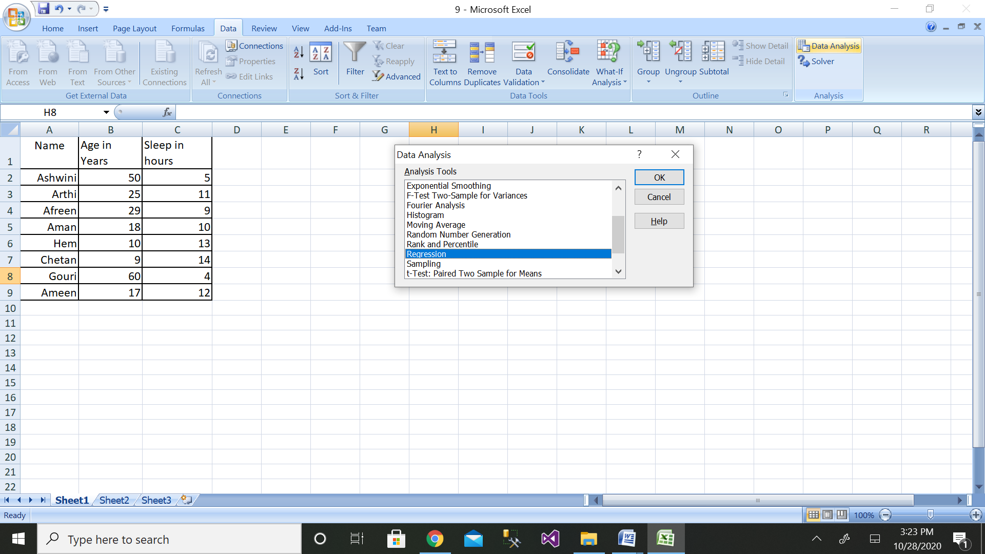

Step 5: Then select the range of dependent variable as shown above

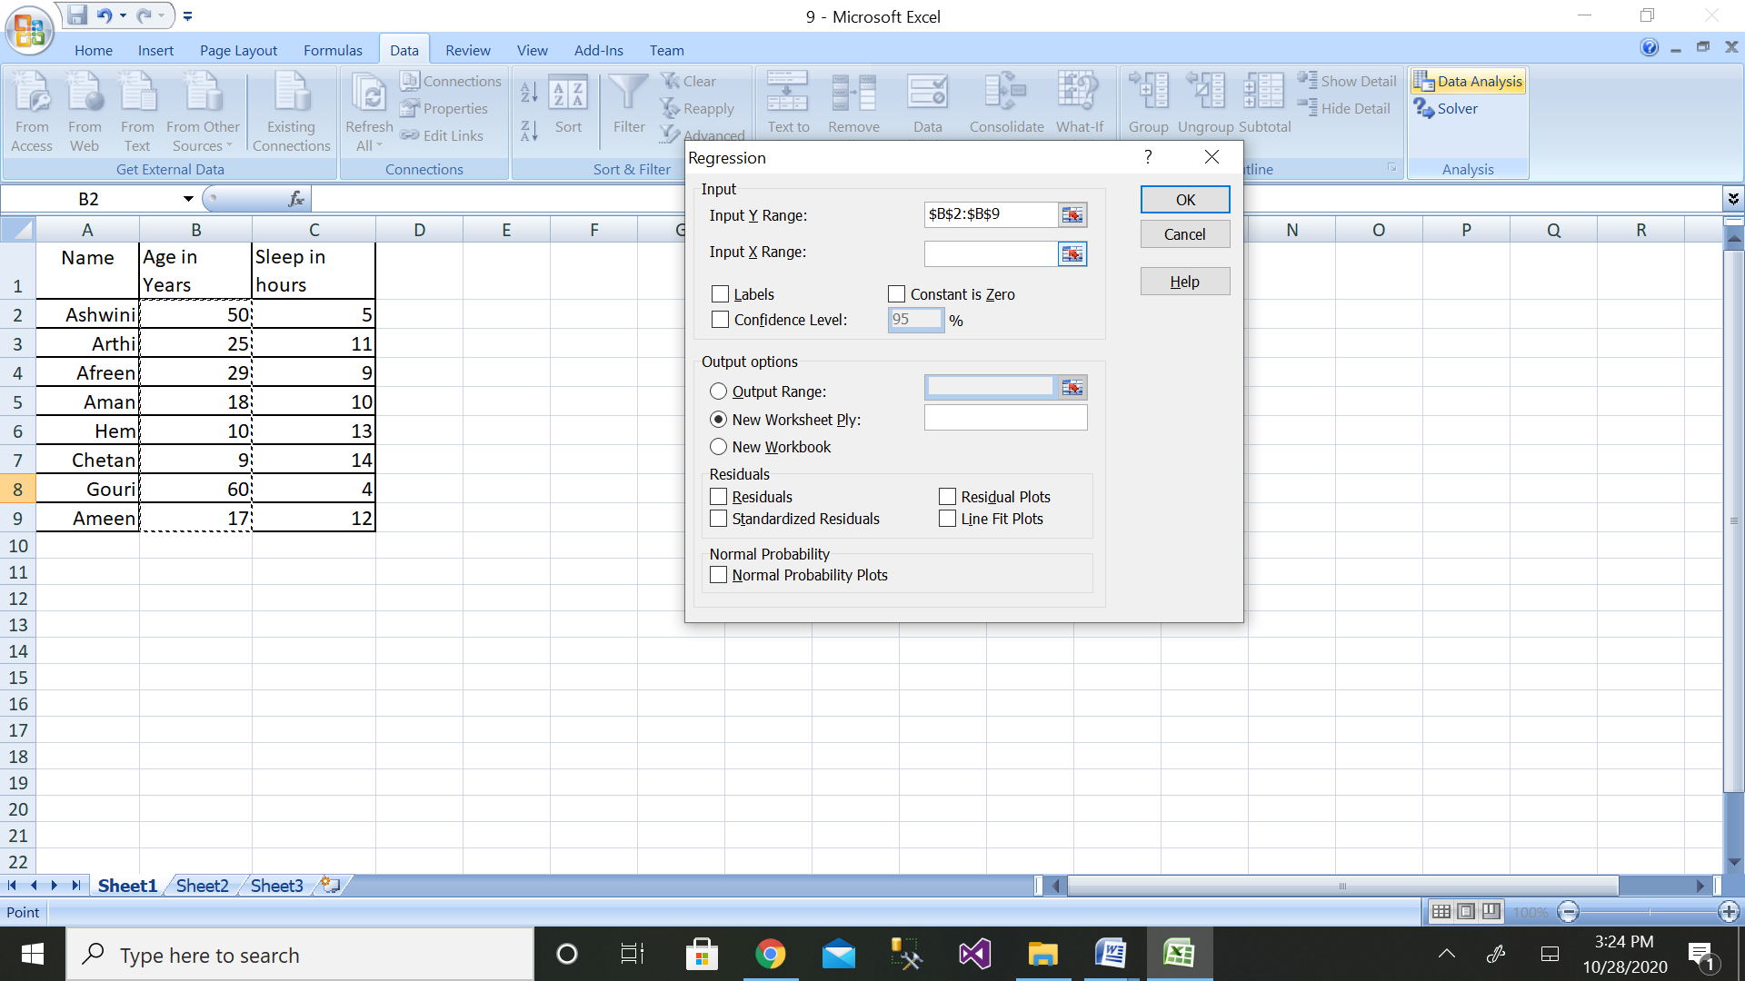

Step 6: After selecting both ranges click on ok button

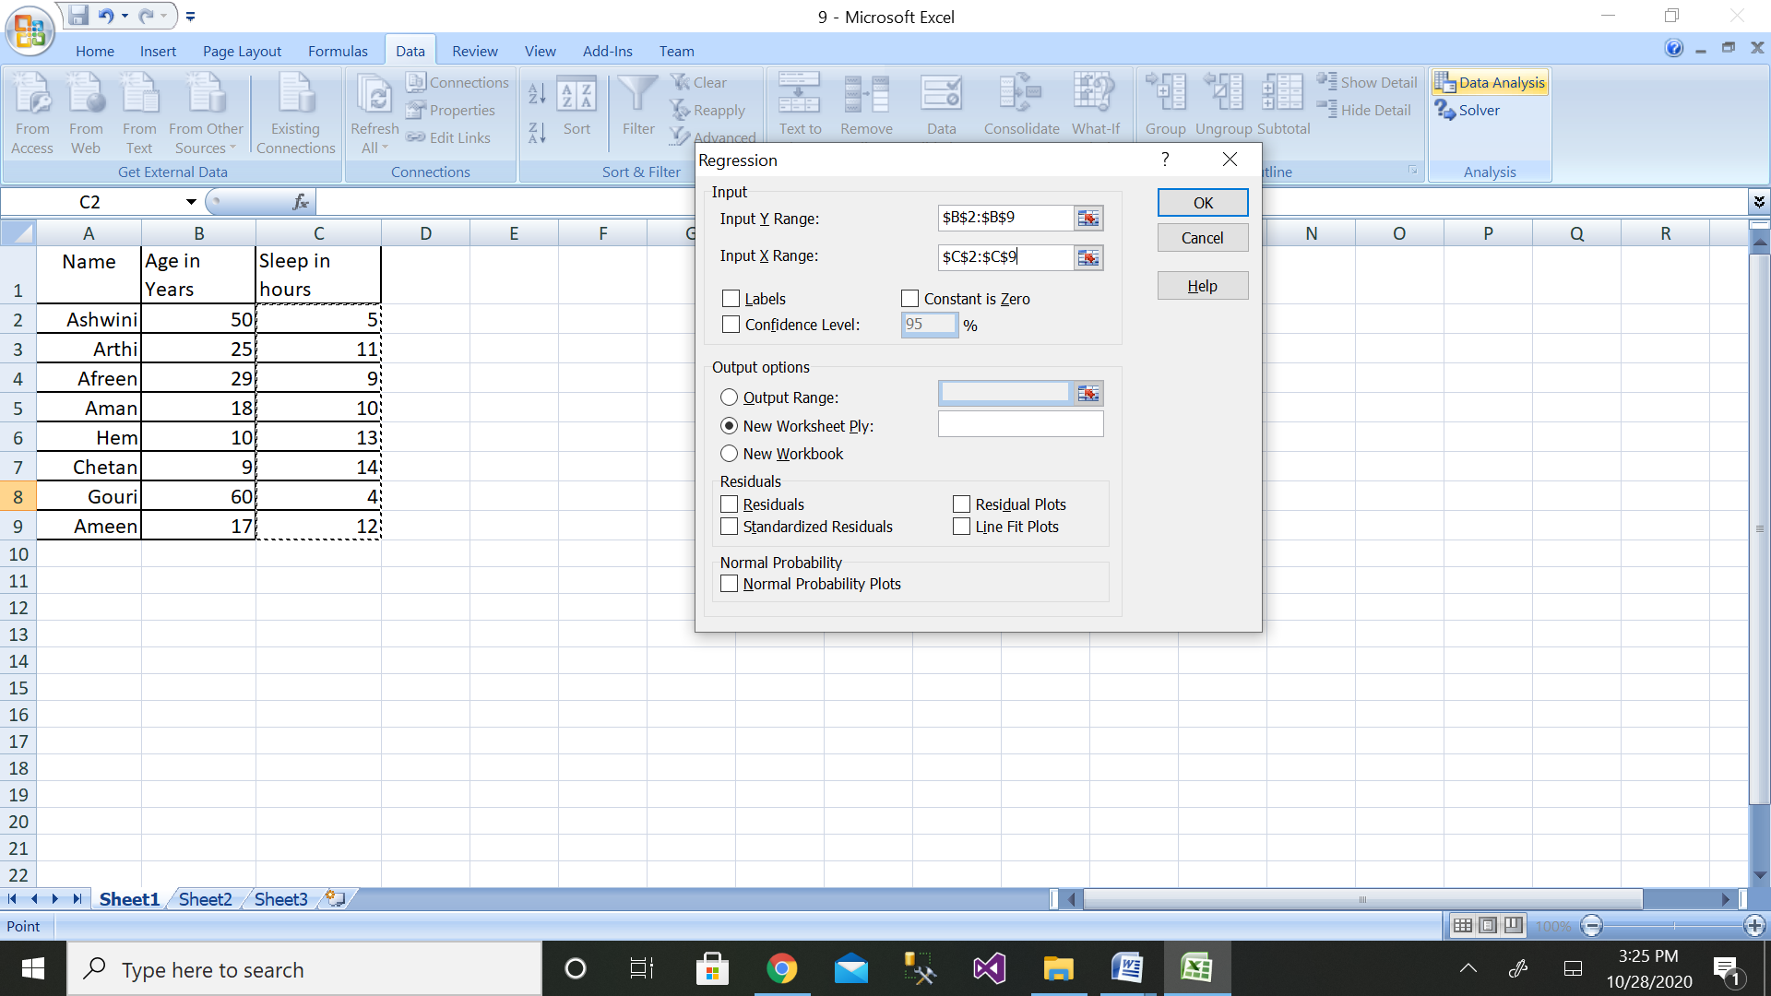

Step 7: We will get the output as shown with residual plot graph

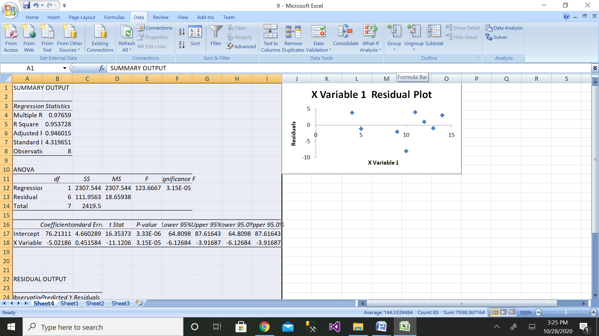

The comparison of values can be done by the above graph.

**10. Apply the linear regression, compare the average salaries of batsman depending on the run rate scored/ recorded in the matches. Assume your own database.**

**Solution:**

Step 1: Salary data have been taken from dataset.

|  |  |  |
| --- | --- | --- |
| Name | Run scored | Salary |
| Ashwini | 2000 | 50000 |
| Arthi | 1000 | 25000 |
| Afreen | 500 | 12500 |
| Aman | 2500 | 65000 |
| Hem | 3000 | 80000 |
| Chetan | 3500 | 90000 |
| Gouri | 1500 | 30000 |
| Ameen | 100 | 10000 |

Step 2: Enter the data for Independent Variable x and dependent variable y as shown above 11 values

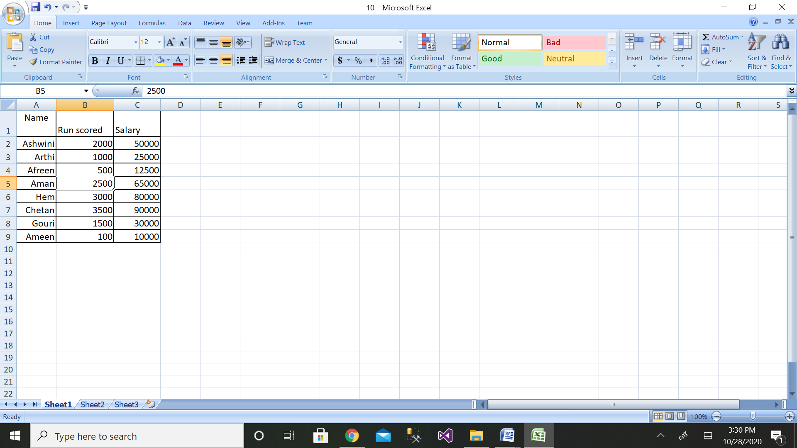

Step 3: Then click on the Data Analysis button

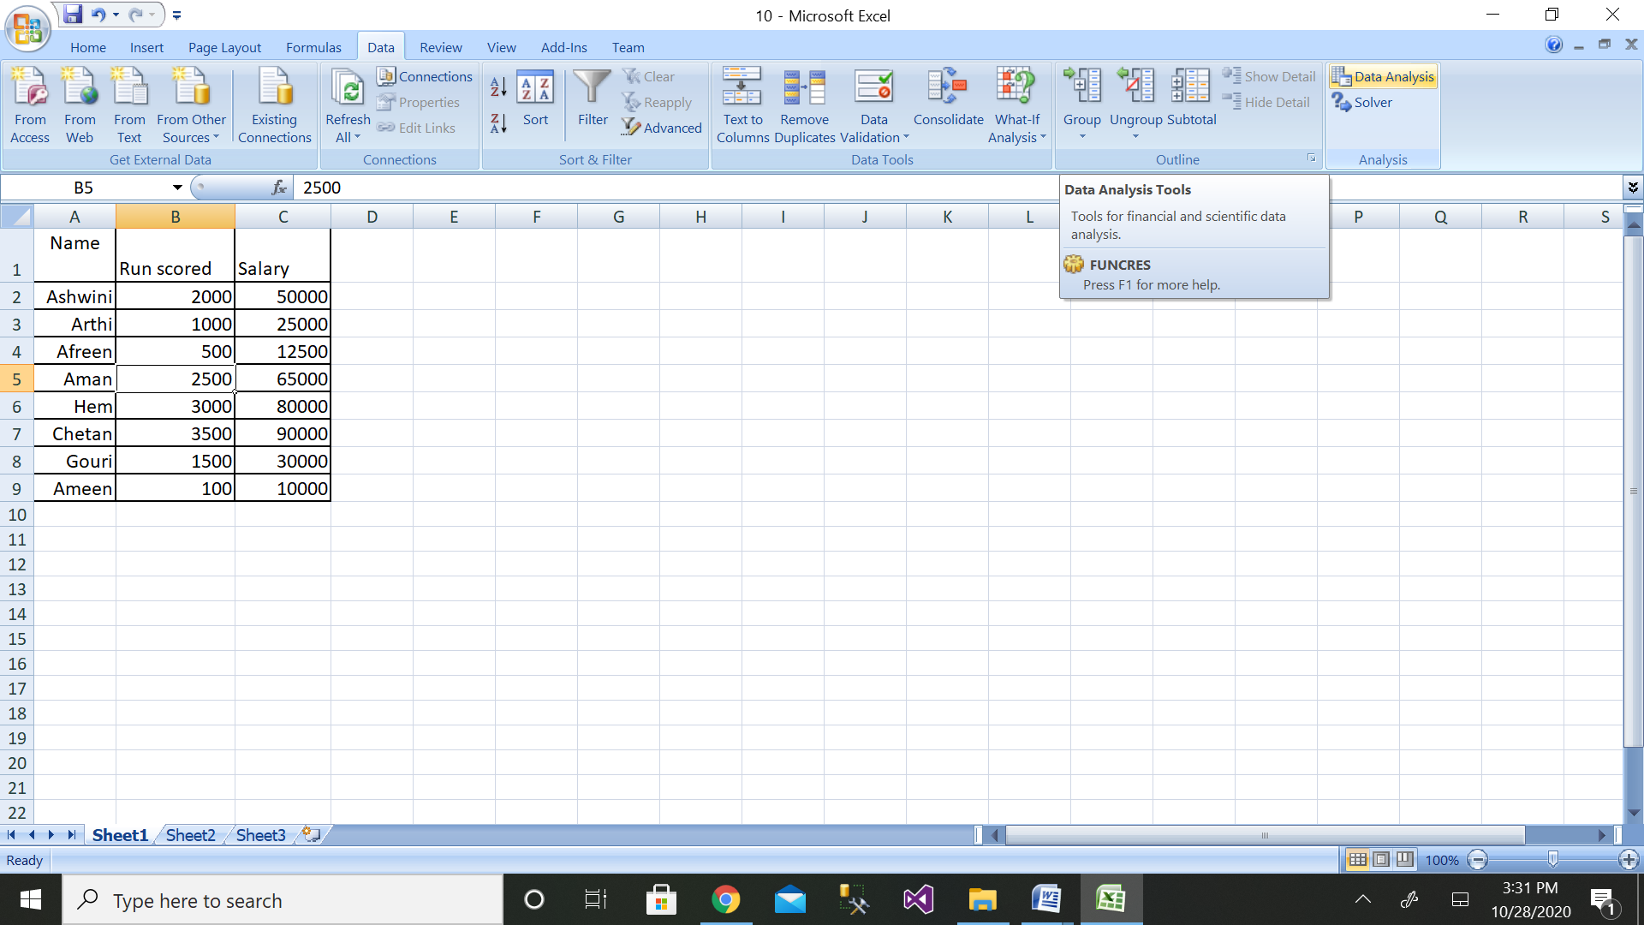

Step 4: Then click on the Regression button

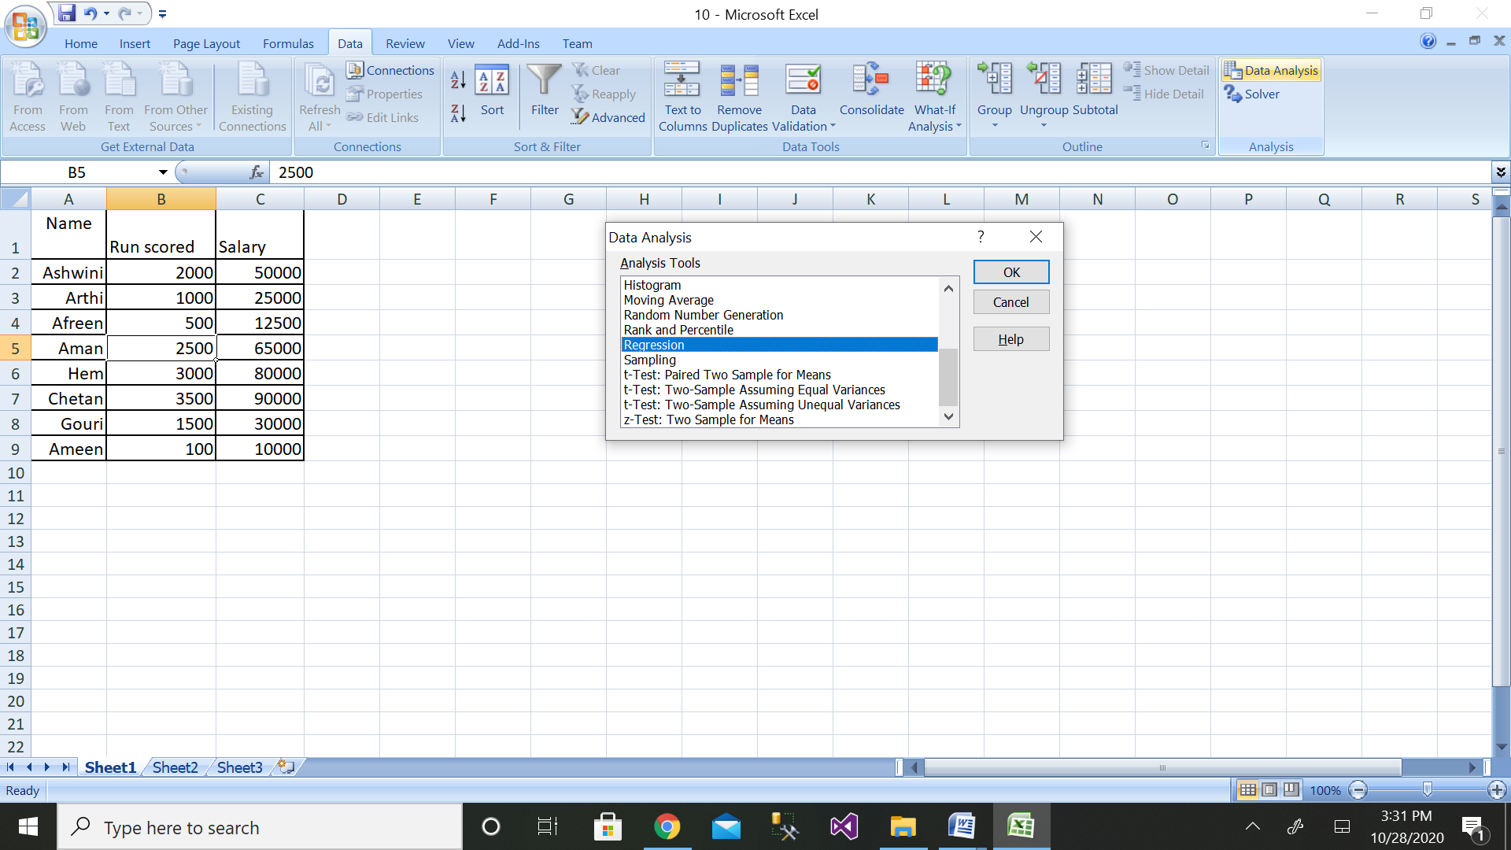

Step 5: Then select the range of dependent variable as shown above

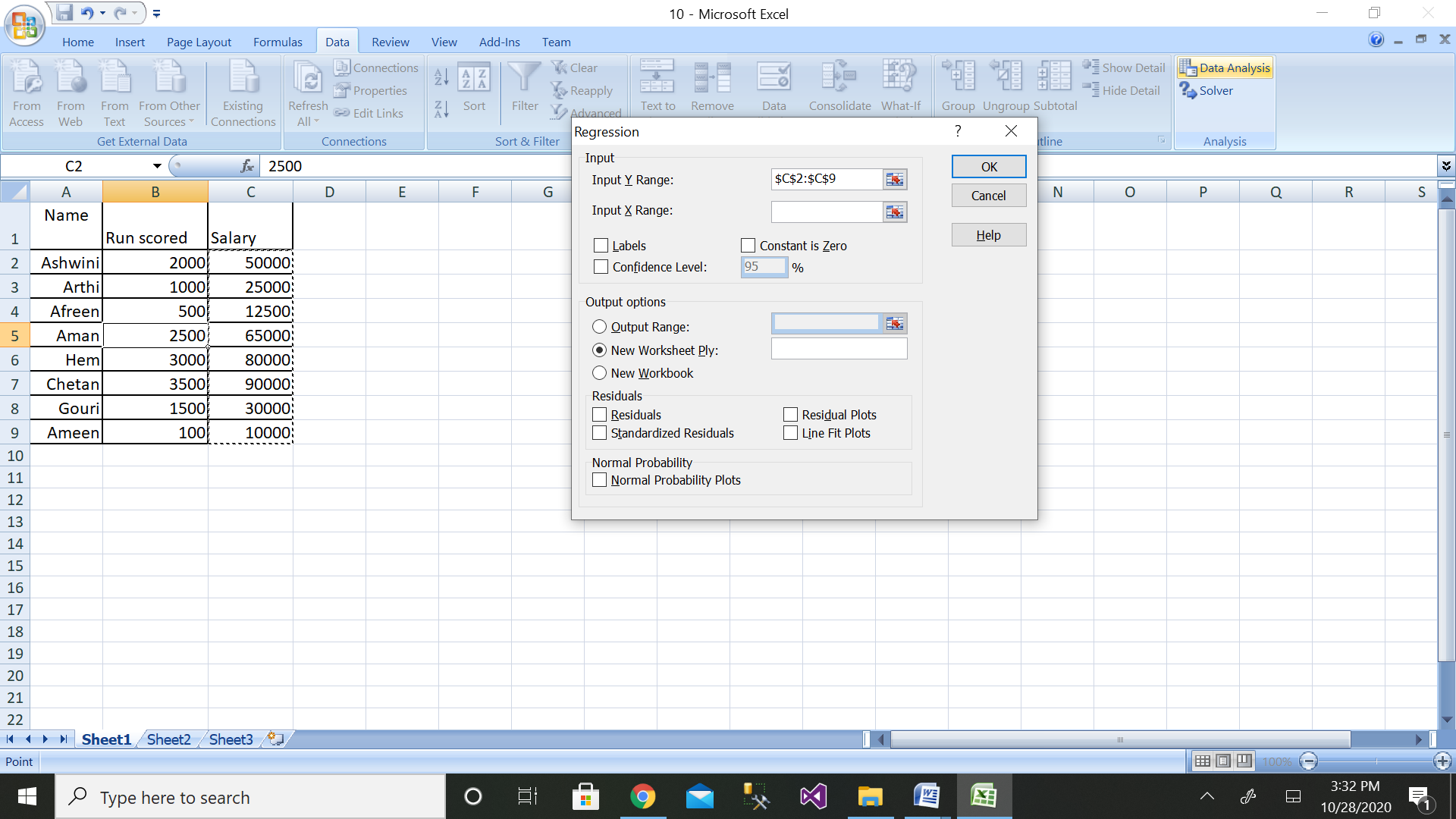

Step 6: After selecting both ranges click on ok button

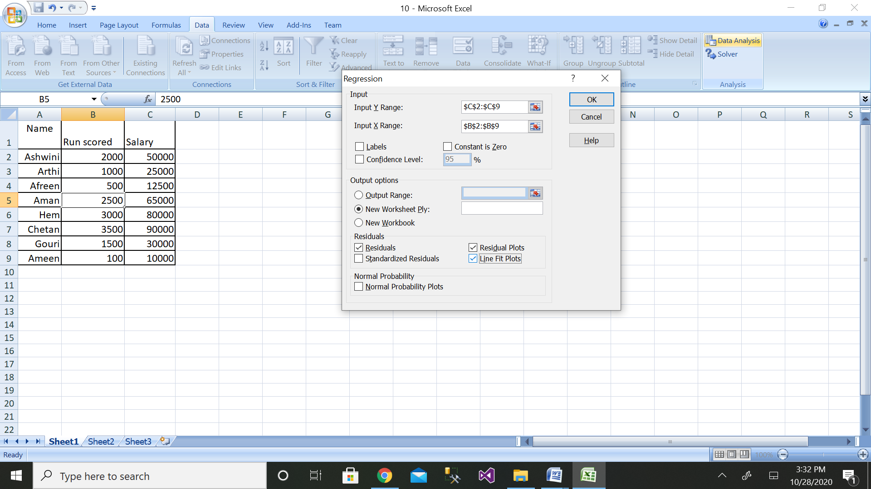

Step 7: We will get the output as shown with residual plot graph

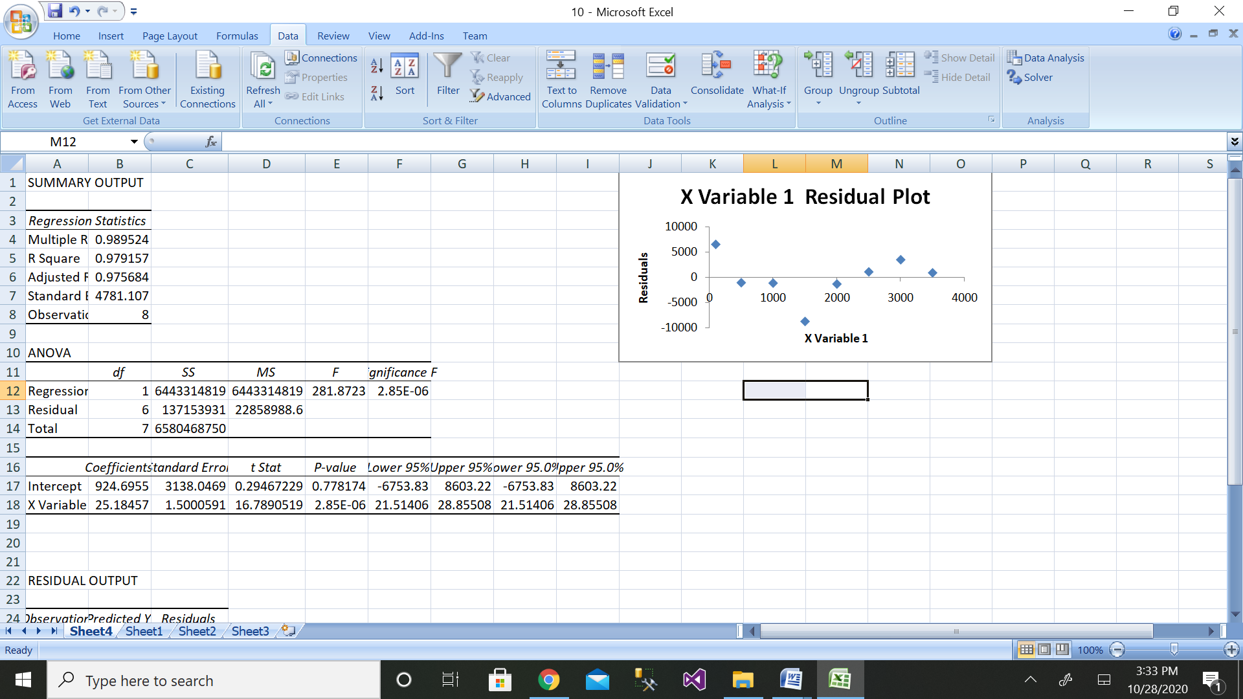

The comparison of values can be done by the above graph.

**11. Design the ER diagram and create schema of the REVA library management system**.

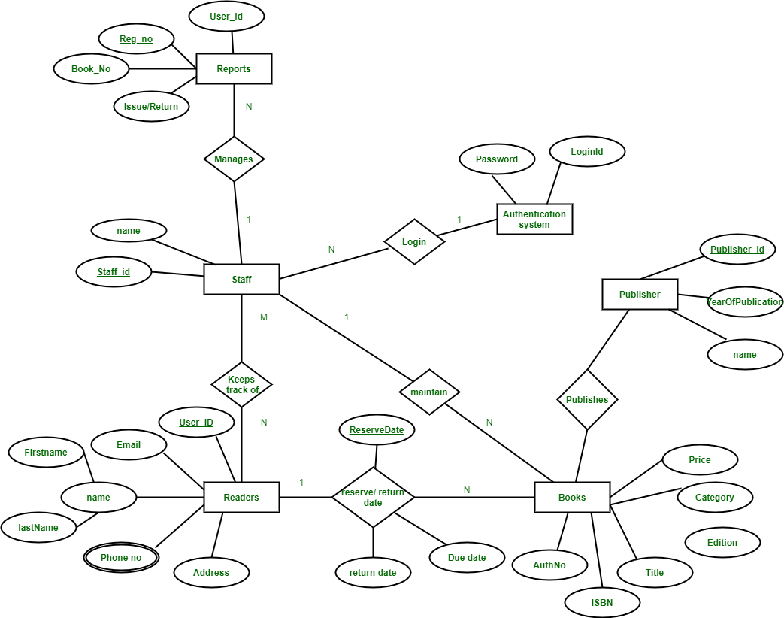

|  |  |
| --- | --- |
| Staff | |
| Name | Staff_id |

|  |  |  |  |  |
| --- | --- | --- | --- | --- |
| Readers | | | | |
| User_id | Name | Phone no | Email | Address |

|  |  |  |  |  |  |
| --- | --- | --- | --- | --- | --- |
| Books | | | | | |
| ISBN | Category | AuthNo | Title | Edition | Price |

|  |  |
| --- | --- |
| Authentication_System | |
| Login_id | Password |

|  |  |  |
| --- | --- | --- |
| Publisher | | |
| Publisher_id | Name | Year of publication |

|  |  |  |  |
| --- | --- | --- | --- |
| Reports | | | |
| User_id | Register_no | Book_no | Issue/Return |

**12. Design the ER diagram and create schema for Hospital Management system.**

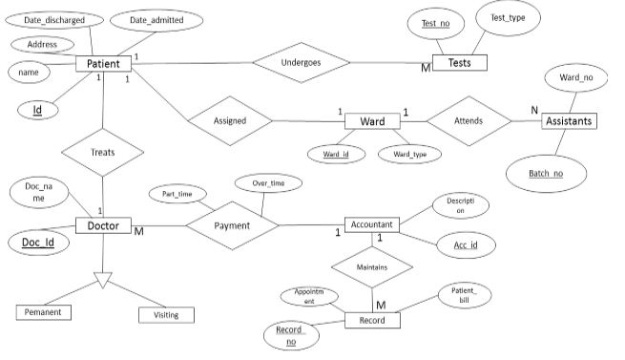

Patient

|  |  |  |  |  |
| --- | --- | --- | --- | --- |
| Id | Name | Address | Date_admitted | Date_discharged |

Doctor

|  |  |
| --- | --- |
| Doc_id | Doc_name |

Record

|  |  |  |
| --- | --- | --- |
| Record_no | Appointment | Patient_bill |

Assistant

|  |  |
| --- | --- |
| Batch_no | Ward_no |

Test

|  |  |
| --- | --- |
| Test_no | Test_type |

Account

|  |  |
| --- | --- |
| Acc_id | Description |

**PART-B**

**Mini-Project**

**Big Mart Sales Forecasting**

Data Science plays a huge role in forecasting sales and risks in the retail sector. Majority of the leading retail stores implement Data Science to keep a track of their customer needs and make better business decisions. Big Mart is one such retailer.

**Problem Statement:** To analyze the Big Mart Sales Data set in order to predict department-wise sales for each of their stores.

**Data Set Description:** The data set used for this project contains historical training data, which covers sales details from 2010-02-05 to 2012-11-01. For the analysis of this problem, the following predictor variables are used:

1. Store – the store number
2. Dept – the department number
3. Date – the week
4. CPI – the consumer price index
5. Weekly_Sales – sales for the given department in the given store
6. IsHoliday – whether the week is a special holiday week

By studying the dependency of these predictor variables on the response variable, you can predict or forecast sales for the upcoming months.

**Logic:**

1. **Import the Data Set:** The data set needed for this project can be downloaded from [Kaggle](https://www.kaggle.com/c/walmart-recruiting-store-sales-forecasting/data).
2. **Data Cleaning:** In this stage, you must make sure to get rid of all inconsistencies, such as missing values and any redundant variables.
3. **Data Exploration:** At this stage, you can plot boxplots and qplots to understand the significance of each predictor variables.
4. **Data Modelling:** For this particular problem statement, since the outcome is a continuous variable (Number of sales), it is reasonable to build a Regression model. The Linear Regression algorithm can be used to solve such problems since it is specifically used to predict continuous dependent variables.
5. **Validate the model:** At this stage, you should evaluate the efficiency of the data model by using the testing data set

**Solution:**

1. Import the data model:

The Big Mart sales obtained from Kaggle website is as shown below:



1. Data Cleaning:

After removing the redundant values, the dataset is as shown below:



1. Data Exploration:

The residual plot is as shown below

1. Data modeling and validation

Using the Regression tool of excel , the dataset obtained is analysed as shown below . The y intercept and Coefficient of regression values are as shown in the below snapshot.

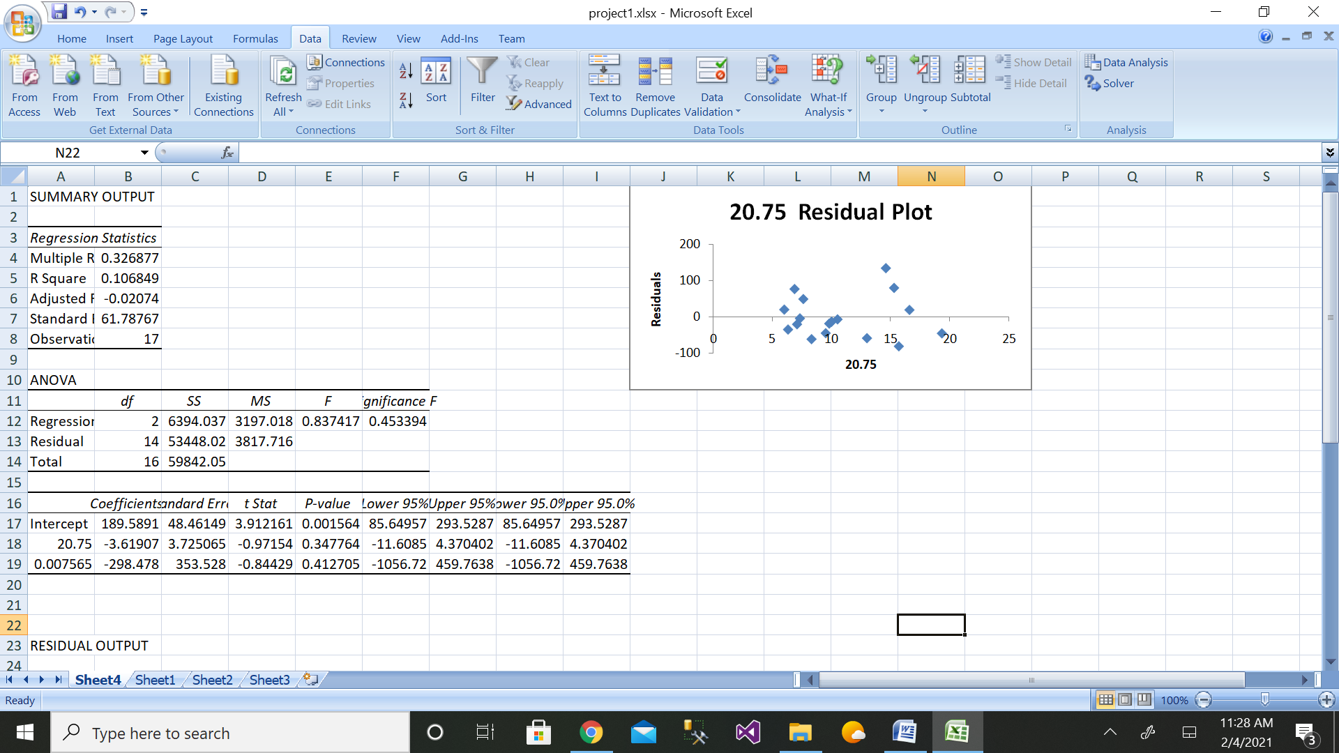

**Bangalore Crime Analysis**

With the increase in the number of crimes taking place in Bangalore, law enforcement agencies are trying their best to understand the reason behind such actions. Analyses like these can not only help understand the reasons behind these crimes, but they can also prevent further crimes.

**Problem Statement:** To analyze and explore the Bangalore Crime data set to understand trends and patterns that will help predict any future occurrences of such felonies.

**Data Set Description:** The dataset used for this project consists of every reported instance of a crime in the city of Bangalore from 01/01/2001

For this analysis, the data set contains many predictor variables such as:

1. ID – Identifier of the record
2. Case Number – The Bangalore Police Chain RD number
3. Date – Date of the incident
4. Description – Secondary description of the IUCR code
5. Location – Location of the occurred incident

**Logic:**

Like any other Data Science project, the below-described series of steps are followed:

1. **Import the Data Set:** The data set needed for this project can be downloaded from [Kaggle](https://www.kaggle.com/currie32/crimes-in-chicago).
2. **Data Cleaning:** In this stage, you must make sure to get rid of all inconsistencies, such as missing values and any redundant variables.
3. **Data Exploration:** You can begin this stage by translating the occurrence of crimes into plots on a geographical map of the city. Graphically studying each predictor variable will help you understand which variables are essential for building the model.
4. **Data Modelling:** For this particular problem statement, since the nature of crimes varies, it is reasonable to build a clustering model. K-means is the most suitable algorithm for this analysis since it is easy to build clusters using k-means.
5. **Analyzing patterns:** Since this problem statement requires you to draw patterns and insights about the crimes, this step mainly involves creating reports and drawing conclusions from the data model.
6. **Validate the model:** At this stage, you should evaluate the efficiency of the data model by using the testing data set and finally calculate the accuracy of the model by using a confusion matrix.

**Solution:**

1. Import the data model:

The Bangalore Crime dataset obtained from Kaggle website is as shown below:



1. Data Cleaning:

After removing the redundant values, the dataset is as shown below:



1. Data Exploration:

The residual plot is as shown below

1. Data modeling and validation

Using the Regression tool of excel , the dataset obtained is analysed as shown below . The y intercept and Coefficient of regression values are as shown in the below snapshot.

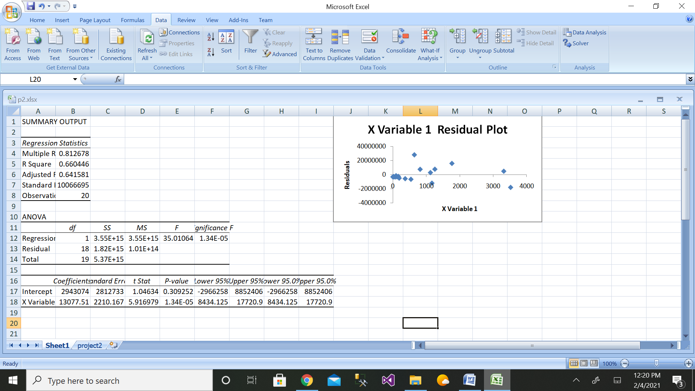

**Additional Projects**

1. Walmarts Sales forcast
2. Movie Recommendation Engine
3. Text Mining
4. Chicago crime Analysis
5. Gender and age detection system
6. Emotion recognition software
7. Customer Segmentation system
8. Android chatbot
9. Movie recommendation system
10. Fraud app detection software

**Appendix**

**Installation Guide**

## What is Microsoft Excel?

Microsoft Excel is a spreadsheet program that is used to record and analyse numerical data. Think of a spreadsheet as a collection of columns and rows that form a table. Alphabetical letters are usually assigned to columns and numbers are usually assigned to rows. The point where a column and a row meet is called a cell. The address of a cell is given by the letter representing the column and the number representing a row.

## How to Open Microsoft Excel?

Running Excel is not different from running any other Windows program. If you are running Windows with a GUI like (Windows XP, Vista, and 7) follow the following steps.

* Click on start menu
* Point to all programs
* Point to Microsoft Excel
* Click on Microsoft Excel

**Follow the following steps to run Excel on Windows 8.1**

* Click on start menu
* Search for Excel N.B. even before you even typing, all programs starting with what you have typed will be listed.
* Click on Microsoft Excel

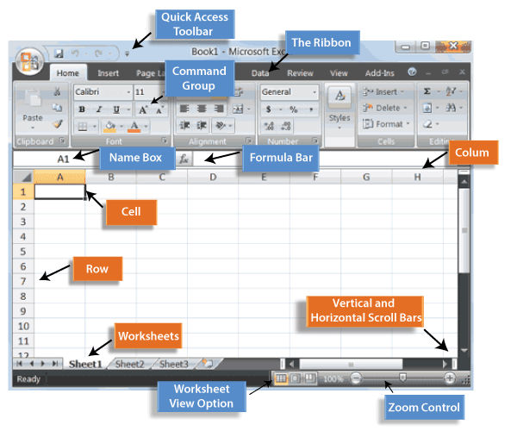

Lab setup to be done before starting the execution of lab programs

**ADDING-IN THE DATA ANALYSIS TOOLPACK TO EXCEL**

Statistical analysis such as descriptive statistics and regression requires the Excel Data Analysis add-in.  
The default configuration of Excel **does not** automatically support descriptive statistics and regression analysis.   
**You may need to add these** to your computer (a once-only operation).

**Excel 2007**: The Data Analysis add-in should appear at right-end of Data menu as Data Analysis.  
If not then

1. Click the **Microsoft Office Button**, and then click **Excel Options**.

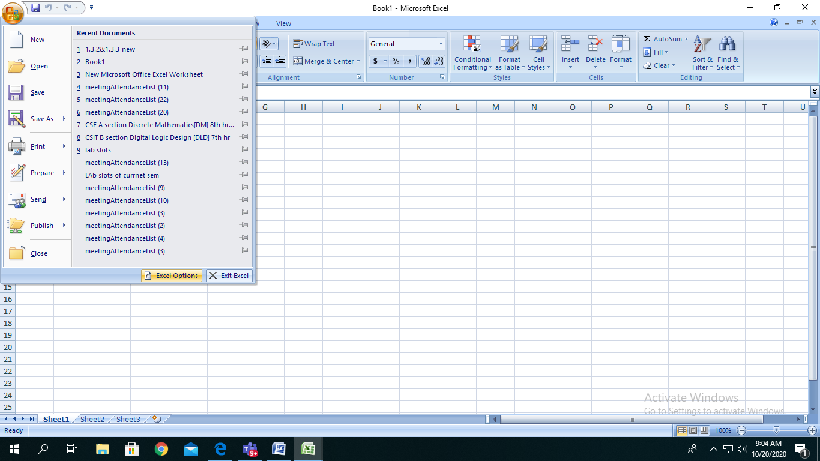

Click on Microsoft office button

2. Click **Add-Ins**, and then in the **Manage** box, select **Excel Add-ins**.

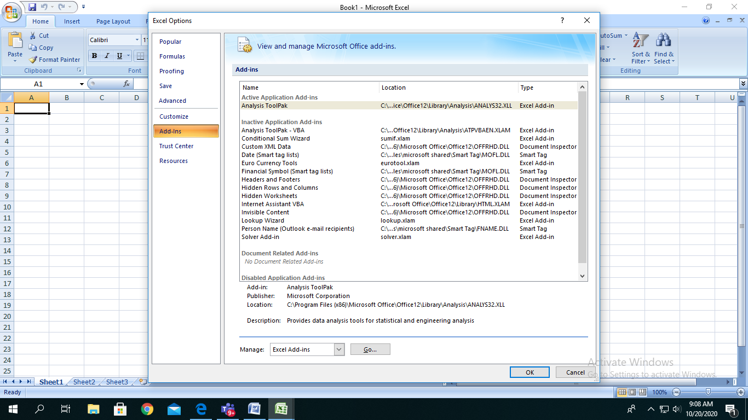

Click on Add on menu

Click on Analysis tool pack

1. Click **Go**.
2. In the **Add-Ins available** box, select the **Analysis ToolPak** check box, and then click **OK**.  
   **Tip**  If **Analysis ToolPak** is not listed in the **Add-Ins available** box, click **Browse** to locate it.  
   If you get prompted that the Analysis ToolPak is not currently installed on your computer, 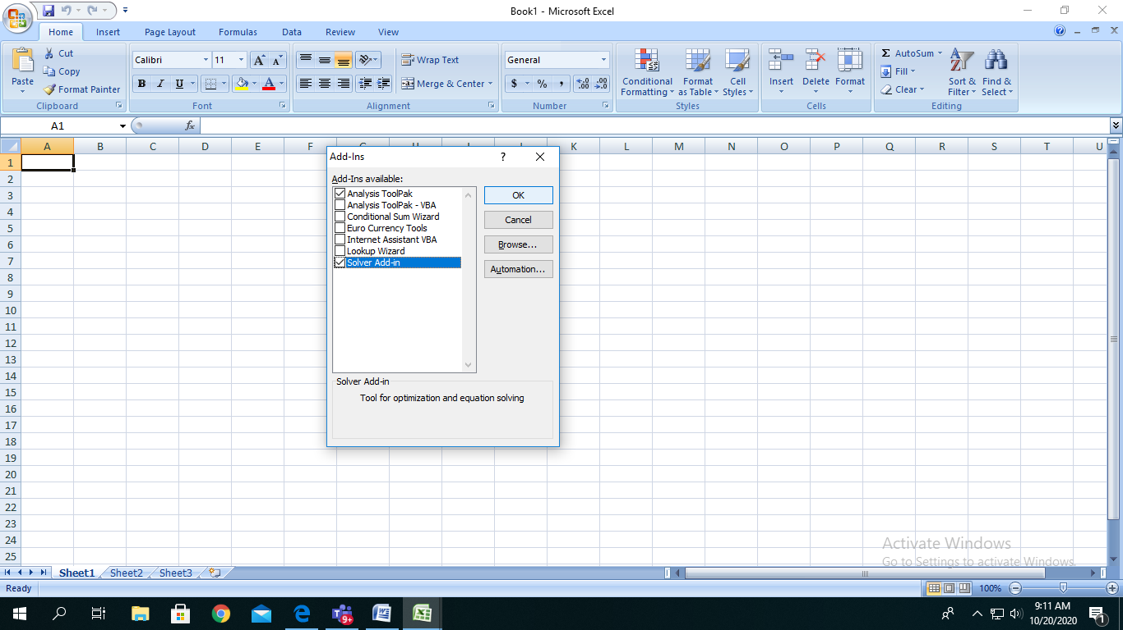
3. click **Yes** to install it.

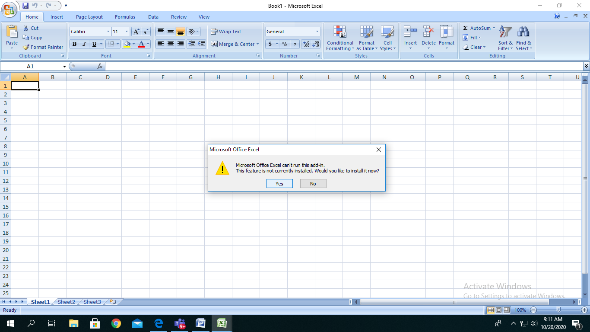

1. After you load the Analysis ToolPak, the **Data Analysis** command is available in the **Analysis** group on the **Data** tab.

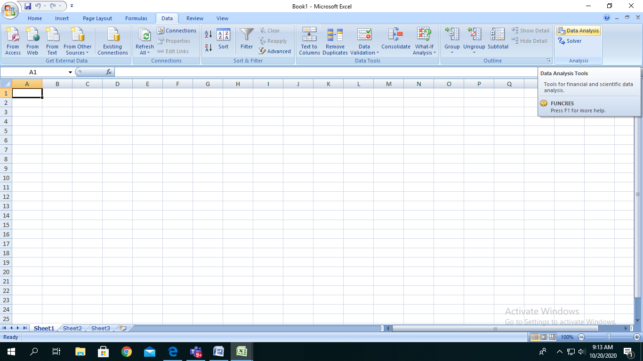

In Data Menu - Data Analysis button will be displayed as shown

This is one time procedure to be followed to add on the Data Analysis button to the Excel. After this procedure is done.